Final Year Design Project
E-Masjid System


By

Dawood Ahmed 2022-KS-158 Haris Ehsan 2022-KS-190

Under the supervision of
Sir Muhammad Kamran

Bachelor of Science in Information Technology (2022-2026)
FACULTY OF COMPUTING & INFORMATION TECHNOLOGY (FCIT),
UNIVERSITY OF THE PUNJAB, LAHORE.

E-Masjid System

A project presented to
University of the Punjab, Lahore

In partial fulfilment
of the requirement for the degree of

Bachelors of Science in Information Technology (2022-2026)

By
Dawood Ahmed 2022-KS-158 | 2022-089264 Haris Ehsan 2022-KS-190 | 2022-089301

FACULTY OF COMPUTING & INFORMATION TECHNOLOGY (FCIT),
UNIVERSITY OF THE PUNJAB, LAHORE

DECLARATION

We hereby declare that this software, neither whole nor as a part has been copied out from any source. It is further declared that we have developed this software and accompanied report entirely on the basis of our personal efforts. If any part of this project is proved to be copied out from any source or found to be reproduction of some other, we will stand by the consequences. No portion of the work presented has been submitted of any application for any other degree or qualification of this or any other university or institute of learning.

Signature: --------------------------- Signature: ------------------------

Student Name 1[089264] Student Name 2 [089301]

CERTIFICATE OF APPROVAL

It is to certify that the final year design project (FYDP) of BSIT “E-Masjid System” was developed by
Dawood Ahmed (2022-KS-158) and Haris Ehsan (2022-KS-190) under the supervision of “Sir Muhammad Kamran” in my opinion; it is fully adequate, in scope and quality for the degree of Bachelors of Science in Information Technology.

Signature:

FYDP Supervisor:

Signatures (Faculty Advisory Committee (FAC)

Signatures
Name
 | FAC1 | FAC2 | FAC3

Signature:

Head of FYDP Coordination Office:

Signature:--------------------------------------- Dated:
Chairperson, Department of Information Technology

Executive Summary
The E-Masjid System is a web based system and is built to help mosques to manage their daily activities in a digital way. In many places, mosques are still using manual registers for the records of donations and expenses and announcements are made only through loudspeakers which reach people within a limited area. This creates problems like lack of transparency, difficulties in keeping records, inconvenience for people who want to donate online. Also people have to visit the mosque physically to meet the religious scholar and tell the date of the nikah ceremony. We are building this project in order to fix these problems by developing an online system which will be easy to use.
The system allows the mosque admin to control the times of prayers, post announcements and also maintain proper records of donations and expenses. Community members can donate online through Stripe, view updates from the mosque, register for events and book Nikah services without physically visiting the mosque. Community members can also choose to keep their name anonymous when donating and can view the donation and expense records of the mosque from the transparency page. Religious scholars also have their own account where they see Nikah booking requests and they accept or reject bookings and pick the final date and time. We built a system to make sure Zakat and Sadaqah money is handled the right way. People who need help can now fill out a request and a committee of trusted members looks at each one to decide who gets the funds. The system also works for several mosques at once. A Mosque Manager can create new mosques and turn them active or inactive when needed. On the homepage, we added a section with photos, campaigns, testimonials and news about events to get the community attention and all these are managed by the mosque admin. The system is easy to use so anyone can work with it, even people who don't know much about computers.

Keywords: Mosque Management System, Donation Transparency, Multi Mosque Support

Acknowledgement
We would like to express our sincere thanks to Sir Muhammad Kamran, Lecturer at Government Graduate College, Civil Lines, Sheikhupura, for his valuable guidance, encouragement and support during the preparation of our project documentation. We are also thankful to our friends and families for their quiet support and motivation, which helped us stay focused throughout this phase of our work.

Signature: --------------------------- Signature: ------------------------

Dawood Ahmed [089264] Haris Ehsan [089301]

Abbreviations
Table 1 Abbreviations

API | Application Programming Interface
CRUD | Create, Read, Update, Delete
FCIT | Faculty of Computing and Information Technology
FR | Functional Requirement
HTTP | HyperText Transfer Protocol
HTTPS | HyperText Transfer Protocol Secure
JSON | JavaScript Object Notation
JWT | JSON Web Token
MERN | MongoDB, Express.js, React.js, Node.js
MVC | Model-View-Controller
NFR | Non-Functional Requirement
SMTP | Simple Mail Transfer Protocol
SMS | Short Message Service
SSL | Secure Sockets Layer
UC | Use Case
UI | User Interface
UML | Unified Modeling Language
URL | Uniform Resource Locator

Table of Contents
Chapter 1 Introduction 13
1. Introduction 14
1.1 Problem Statement 14
1.2 Problem Solution 14
1.3 Objectives of the Proposed System 15
1.4 Scope 15
1.5 System Components 16
1.6 Related System Analysis/Literature Review 18
1.7 Vision Statement 18
1.8 System Limitations and Constraints 19
1.9 Tools and Technologies 20
1.10 Project Deliverables 20
1.11 Project Planning 21
1.12 Summary 21
Chapter 2 Requirements Analysis 22
2. Analysis 23
2.1 User classes and characteristics 23
2.2 Requirement Identifying Technique 23
2.3 Functional Requirements 24
2.4 Non-Functional Requirements 35
2.5 External Interface Requirements 36
2.6 Use case Analysis 38
Use Case Diagram 53
Storyboards 58
2.7 Summary 60
Chapter 3 61
3. System Design 62
3.1. Design considerations 63
3.2. Design Models 64
Design Class Diagram 64
64
Sequence Diagram 65
State Transition Diagram 67
3.3. Architectural Design 70
3.4. User Interface Design 79
3.5 Design Decisions 85
3.6 Summary 86
Chapter 4 Implementation 87
4. Implementation 88
4.1. Algorithm 88
4.2. External APIs/SDKs 91
4.3. Code Repository 91
4.4. Summary 92
Chapter 5 93
5. Introduction 94
5.1 Unit Testing (UT) 94
5.2 Functional Testing (FT) 98
5.3 Integration Testing (IT) 105
5.4 Performance Testing (PT) 109
5.5 Summary 110
Chapter 6 111
6.1. Conversion Method 112
6.2. Deployment 112
6.3. Post Deployment Testing 114
6.4. Challenges 115
6.5. Summary 116
Chapter 7 Conclusion 117
7. Introduction 118
7.1. Evaluation 118
7.2. Traceability Matrix 119
7.3. Conclusion 120
7.4. Future Work 120
References 121

List of Tables

Table 1 Abbreviations 7
Table 2 Related System Analysis with proposed project solution 18
Table 3 Tools Technologies and Libraries 20
Table 4 User classes 23
Table 5 Functional Requirement 1 24
Table 6 Functional Requirement 2 24
Table 7 Functional Requirement 3 25
Table 8 Functional Requirement 4 26
Table 9 Functional Requirement 5 26
Table 10 Functional Requirement 6 27
Table 11 Functional Requirement 7 27
Table 12 Functional Requirement 8 28
Table 13 Functional Requirement 9 29
Table 14 Functional Requirement 10 29
Table 15 Functional Requirement 11 30
Table 16 Functional Requirement 11 31
Table 17 Functional Requirement 13 31
Table 18 Functional Requirement 14 32
Table 19 Functional Requirement 15 33
Table 20 Functional Requirement 16 33
Table 21 Functional Requirement 17 34
Table 22 Use Case 1 38
Table 23 Use Case 2 39
Table 24 Use Case 3 39
Table 25 Use Case 4 40
Table 26 Use Case 5 41
Table 27 Use Case 6 41
Table 28 Use Case 7 42
Table 29 Use Case 8 42
Table 30 Use Case 9 43
Table 31 Use Case 10 44
Table 32 Use Case 11 44
Table 33 Use Case 12 45
Table 34 Use Case 13 45
Table 35 Use Case 14 46
Table 36 Use Case 15 46
Table 37 Use Case 16 47
Table 38 Use Case 17 48
Table 39 Use Case 18 48
Table 40 Use Case 19 49
Table 41 Use Case 20 50
Table 42 Use Case 21 50
Table 43 Use Case 22 51
Table 44 Use Case 23 52
Table 45 Use Case 24 53
Table 46 Data Dictionary 74
Table 47 Record Donation Algorithm 88
Table 48 Submit Zakat Request Algorithm 88
Table 49 Committee Review Decision Algorithm 89
Table 50 Admin Finalize Fund Request Algorithm 89
Table 51 Process Online Donation Algorithm 90
Table 52 User Login Algorithm 90
Table 53 User Register Algorithm 91
Table 54 Testcase User Registration 94
Table 55 Testcase Anonymous Donation Recording 94
Table 56 Testcase Fund Request Reason Length Validation 95
Table 57 Testcase Password Strength Validation 96
Table 58 Testcase Donation Type Validation 96
Table 59 Testcase Donation Minimum Amount Validation 97
Table 60 Testcase Online Donation using Stripe 98
Table 61 Testcase Fund Request Submission 98
Table 62 Testcase Committee Vote on Fund Request 99
Table 63 Testcase Mosque Manager Creates Mosque 100
Table 64 Testcase Homepage Marketing Sections 100
Table 65 Testcase User Login 101
Table 66 Testcase Admin Finalizes Fund Request 102
Table 67 Testcase Multi tenant Data Isolation 103
Table 68 Testcase Anonymous Donation 103
Table 69 Testcase Religious Scholar Accepts Nikah Booking 104
Table 70 Testcase Fund Request 105
Table 71 Testcase Multi tenant Data Isolation 106
Table 72 Testcase Stripe Online Donation 106
Table 73 Testcase New User Registration to First Donation 107
Table 74 Testcase Cross role Login Force Logout 108
Table 75 Testcase Prayer Times Page Load 109
Table 76 Transparency Page Load with Records 109
Table 77 Testcase Homepage Limited Data Fetches 110
Table 78 Evaluation 118
Table 79 Traceability Matrix 119

Tables of Figures

Figure 1 Gantt chart 21
Figure 2 Use Case diagram of Community members 54
Figure 3 Use Case diagram of Mosque Admin 55
Figure 4 Use Case diagram of Religious Scholar 56
Figure 5 Use case diagram of Mosque Manager 57
Figure 6 Use Case diagram of Committee Members 57
Figure 7 Online Donation Storyboard 58
Figure 8 Event Management Storyboard 59
Figure 9 Nikah booking Storyboard 59
Figure 10 Class Diagram 64
Figure 11 Login Sequence Diagram 65
Figure 12 Online Donation Sequence Diagram 65
Figure 13 Nikah Booking Sequence Diagram 66
Figure 14 Admin Update Prayer Times Sequence Diagram 66
Figure 15 User Account State Diagram 67
Figure 16 Nikah Booking Status State Diagram 68
Figure 17 Event State Diagram 69
Figure 18 Architectural diagram 70
Figure 19 Component diagram 71
Figure 20 Hero Section design 80
Figure 21 Login page design 81
Figure 22 Donation Transparency page design 82
Figure 23 Admin Dashboard design 83
Figure 24 Scholar page design 83

Chapter 1 Introduction

Introduction
This chapter is an introduction about our Final Year Project E-Masjid System. We explain the reason why we chose this project and what problems will be solved. We also list the tools that we will be using and how our team members will be working together on this project. This chapter gives the complete overview of our project idea.

Problem Statement
People who donate to the mosque do not know where their donations are used and how they are used. People who want to donate online have no easy way to do it from home. When families need nikah service, they have to visit physically to get nikah registrar. People who are away from their area mosque do not get the updates about announcement and events are going to happen. Right now, many mosques do not have a clear way to handle Zakat and Sadaqah requests. People who need help do not know where to go and the money is often given out without any real records. Another big problem is using paper registers for keeping records. This method is slow and if the register get lost or damaged then all important information is gone forever.

Problem Solution
The E-Masjid System solves these problems by providing a complete web-based platform where a mosque administrator can manage prayer times, donations, expenses, events, announcements and more. Religious scholars have their own dashboard where they see Nikah booking requests and they accept or reject and pick the final date and time. Community members can view updates, register for events, donate online, and book Nikah services. Community members can also choose to keep their name anonymous when they donate and see the donation and expense records of the mosque from a transparency page. Visitors can pick which mosque they want to see from a dropdown in the navbar. To handle Zakat and Sadaqah money, the system offers a request workflow where needy people apply and the committee members each vote on a request, then the admin finalizes based on the tally. For management of multiple mosques, a Mosque Manager role is included. The homepage contains a promotional section to attract community participation and the mosque admin manages all this content.

Objectives of the Proposed System

- To make a web based system for mosque management using MERN stack.
- To manage donations in a clear way and record of where money is spent. Also people can donate online.
- To show daily prayer times and special timings for Jummah and Ramadan.
- To make an event section for community programs.
- To make online Nikah booking system where religious scholars can accept or reject the request.
- To give different access to mosque manager, admin, committee member, religious scholar and normal users for security and management.
- To implement multiple mosque system and to give access of features for each mosque.
- To develop a Zakat and Sadaqah request system where committee members each vote and admin finalizes based on votes.
- To let community members donate without showing their name and a transparency page where they can see all donations and expenses.
- To let the mosque admin manage the homepage content which includes hero slides, campaigns and testimonials.

Scope

In-scope
- Daily and special prayer times management.
- Announcements management
- Donation tracking with anonymous option and expense recording by admin
- Create an event and registration system
- Marketing content management like hero slides, campaigns and testimonials on homepage
- Online booking system for Nikah services where religious scholars can accept or reject requests.
- User authentication for mosque manager, admin, committee member, religious scholar and community members with forgot password.
- Needy user can send fund request and committee members vote on requests and the admin finalizes based on votes
- Multi mosque management with data isolation per mosque and visitor mosque selector
- Public financial transparency view with PDF report download
- Online payment gateway integration via Stripe Checkout and responsive design for mobile and desktop

Out-of-scope
- Mobile app for E-masjid system.
- Automated SMS system.

System Components
The E-masjid system has six modules and they are described below:

Module 1: Community Web App
- View prayer times without login.
- Register, log in and forgot password
- View announcements and register events.
- View donation and expense transparency reports.
- Make online donation and user can keep the name as anonymous.
- View marketing content like hero slides carousel, campaigns and testimonials.
- Book Nikah services and check booking status.
- Submit Zakat or Sadaqah request and view request status.

Module 2: Mosque Admin Dashboard
- Log in to admin panel.
- Manage daily prayer times and special prayers.
- Record cash donations and expenses.
- Post announcements and manage events.
- Manage religious scholar accounts.
- Create and manage committee members.
- View all Zakat or Sadaqah requests, see committee votes and finalize based on votes

Module 3: Religious Scholar Dashboard
- Log in.
- View pending Nikah booking requests.
- Accept or reject bookings.

Module 4: Mosque Manager Dashboard
- Log in with manager role.
- Create and manage multiple mosque profiles.
- Mosque manager can activate or deactivate for each mosque.
- Create admin accounts for any mosque under management.
- View overall platform stats like total masjids and active vs inactive mosques

Module 5: Committee Review Dashboard
  - Log in as committee member.
  - Receive email notification for new Zakat requests.
  - Review request details and vote approve or reject with optional note. Admin then finalizes based on votes
  - View history of reviewed requests.

Module 6: Marketing Content Management
  - Log in as admin
  - Manage campaigns
  - Manage testimonials
  - Manage hero slides
  - All marketing content is scoped per mosque

Related System Analysis/Literature Review

Table 2 Related System Analysis with proposed project solution

Application Name | Weakness | Proposed Project Solution
Existing mosque apps | No multi mosque management, no proper Zakat request handling | E-Masjid provides a Mosque Manager role for multi mosque management and a full Zakat request management system.
Church management systems | Focus on church management and lack nikah request service | E-Masjid provides Islamic features like nikah booking, zakat request and prayer time management.
Common charity platforms | Donations go to a central fund, there is no record of local mosque expenses, and no committee member to manage Zakat fund requests. | E-Masjid provides financial transparency for each mosque and a review committee to decide on Zakat fund requests.
Generic online donation platform | No integration with mosque operations like prayer times, Nikah, events | E-Masjid combines online donations with full mosque operations in one platform

Vision Statement
For mosque committees, administrators, religious scholar and community members Who need a digital system to manage mosque operations, financial transparency and social services like zakat handling and nikah bookings The E-Masjid System Is a mosque management platform That enables multi mosque system, transparent donation and expense records and community engagement through events and promotional content and proper zakat and sadaqah request handling Unlike paper registers or separate single purpose apps Our product offers a simple interface with role-based security for all 5 user roles.

System Limitations and Constraints

Limitations:
Following are the limitations:
- Cannot work without internet connection.
- No SMS notifications for announcements.
- No mobile app version.
- Payment system requires card payments only.
- Dependent on third party services like stripe for payments and Resend email service for committee notifications
- Requires modern browser because system uses React 18 and Vite which need recent JavaScript

Constraints:
Following are the constraints:
- Committee members must have email addresses and basic web knowledge.
- Marketing content must be managed by the mosque admin.
- Zakat request verification is manual by the committee.
- Anonymous donations still record the donor in the backend for audit purposes but the name is hidden publicly

Tools and Technologies

Table 3 Tools Technologies and Libraries

Tools, Libraries, And Technologies | Tools | Version | Rationale
Tools, Libraries, And Technologies | VS Code,  Postman, Draw.io, Git, GitHub | Latest | Code editor, Architecture and flow diagrams, Version control, API testing
Tools, Libraries, And Technologies | Libraries | Version | Rationale
Tools, Libraries, And Technologies | React.js, Vite, Express.js,  Tailwind CSS, JWT, Mongoose | Latest | Frontend framework, backend framework and database schema modelling
Tools, Libraries, And Technologies | Technology | Version | Rationale
Tools, Libraries, And Technologies | Nodejs, JS, Mongo DB, Stripe API, Nodemailer | Latest | Full stack web application

Project Deliverables
- Complete working E-Masjid web application with all features running.
- User registration , login system and forgot password with different roles like admin, mosque manager, religious scholar, committee member, community member.
- Prayer times management module where admin sets daily and special prayers like Eid, Ramadan and Shab events.
- Donation recording module for cash and online donations with anonymous option.
- Expense record module with categories.
- Financial transparency page showing income, expenses, and balance with pdf report download
- Event and announcement management system.
- Nikah booking system with scholar accept or reject the request.
- Zakat and sadaqah request submission form for community members.
- Committee dashboard where members can vote for requests and admin finalizes based on votes
- Multi mosque management dashboard for a mosque manager to control multiple mosques and create admins in any of the managed mosques.
- Multi mosque UI selector for visitors and responsive design that works on mobile phones, tablets and computers.
- Online payment integration using stripe for donations.
- Marketing content management like campaigns, testimonials and hero slides
- Software Requirements Specification (SRS) document.
- Software Design Specification (SDS) document with all diagrams.

Project Planning
We divided the project into 8 tasks starting from the project proposal in October 2025 and ending with bug fixes in September 2026. The figure below shows each task with its start date, end date and total days.

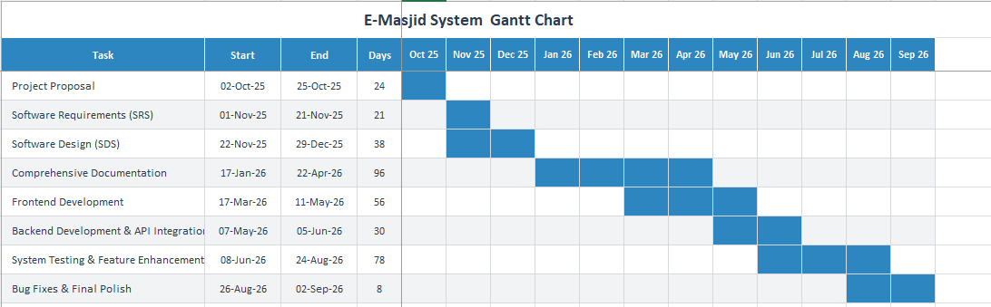

Summary
Figure 1 Gantt chart

In this chapter, we introduced the E-Masjid System. We explained the problems mosques face today and how our system solves them. We defined 10 objectives, the scope, the 6 system modules, and compared our work with existing systems. We wrote our vision, the limitations, the tools we used, and the project deliverables.

Chapter 2 Requirements Analysis

Analysis
This section explains the detailed requirements for the E-Masjid System. The purpose of this chapter is to explain what our system will do, who will use it and how it should work for each type of user. This analysis helps us to understand what features to build and how they should work for different types of users.

User classes and characteristics

Table 4 User classes

User Class | User Characteristics
Mosque Manager | This is the super admin of the whole system. He manages multiple mosques under one platform and creates admin accounts for those mosques.
Mosque Administration | Mosque admin who manages day to day operations of a single mosque like prayers, donations, events and announcements.
Committee Member | A trusted person selected by the masjid admin to review zakat and sadaqah requests. Committee members receive email notifications when a new request  comes, log in to a dashboard and vote on each request to approve or reject with an optional note. The admin finalizes based on the votes.
Community  Members | Local people who visit the mosque. View prayer times, announcements and events. Can donate, book Nikah and submit Zakat or Sadaqah requests.
Religious  Scholars | Islamic scholars who perform nikah ceremonies. View pending Nikah bookings, accept or reject and pick the final ceremony date and time.

Requirement Identifying Technique
To find out what our E-Masjid System should do, we used different methods to understand what users really need. First, we talked to the imam and listened to the problems related to the mosque. They told us about manual record keeping, lack of transparency in donations, zakat and sadaqah handling and how difficult it is to manage events. Then we used the Use Case technique because our system is an interactive website where different users do different things. This helped us understand how mosque manager, mosque admins, committee members, religious scholars and community members will use the system. We made use case diagrams to show all the main features clearly.

Functional Requirements
We identified 17 main functional requirements for our system. Each feature has specific functional requirements that explain what the system should do. These requirements are written from users view to clearly explain the expected behavior.

Functional Requirement 1
Table 5 Functional Requirement 1

Identifier | FR-1
Title | User Registration and Login
Requirement | The system will allow users to register and login with email and password, with different access levels for mosque manager, admin, Religious Scholar, committee members and community members. Before account is created, system sends a 6 digit code to the email for community user and user has to enter it correctly to verify the email.
Source | System security needs
Inputs | Email, password, name, phone number, user role, verification code
Destination | User data is stored in database and login result is shown on screen
Outputs | Successful registration and login message or error message
Rationale | To protect sensitive information and manage permissions
Business Rule | Mosque manager creates mosques, admin manage a mosque, community users, committee member and religious scholar have limited access. Email must be verified for community user with the code before account is created.
Dependencies | None
Priority | High

Functional Requirement 2
Table 6 Functional Requirement 2

Identifier | FR-2
Title | Record Donations
Requirement | The mosque admin will be able to record cash donations with donor name, amount, date, phone, note and donation type. A donation can be marked as anonymous by the donor.
Source | Mosque committee discussion
Inputs | Donor name, amount, date, donation type, phone, note
Destination | Saved in donations collection in database
Outputs | Donation record created and success message shown
Rationale | To maintain proper records and show transparency
Business Rule | Each donation must have at least donor name and amount
Dependencies | FR-1
Priority | High

Functional Requirement 3
Table 7 Functional Requirement 3

Identifier | FR-3
Title | Record Mosque Expenses
Requirement | Admin can add where mosque money is spent like for repairs, electricity etc.
Source | Discussions with mosque imam about community trust issues.
Inputs | Expense description, amount, date, category
Destination | Saved in expenses collection
Outputs | Expense record added successfully
Rationale | Community wants to see how their donations are being used
Business Rule | Every expense must have description, amount, and date
Dependencies | FR-1
Priority | High

Functional Requirement 4
Table 8 Functional Requirement 4

Identifier | FR-4
Title | Show Donation and Expense Reports
Requirement | The system will show donation records, expense details, and financial reports so people can see both income and spending. Community can view transparency page and download PDF report.
Source | Discussions with mosque imam about community trust issues.
Inputs | Selection of report date or month
Destination | Displayed on admin and user dashboard
Outputs | List of donations, list of expenses, total income, total expenses
Rationale | People want to see where their money is spent.
Business Rule | Reports should show income vs expenses clearly.
Dependencies | FR-2, FR-3
Priority | High

Functional Requirement 5
Table 9 Functional Requirement 5

Identifier | FR-5
Title | Event & Announcement Management
Requirement | The admin will be able to add, update, or remove events and announcements such as Islamic classes, community programs, and Eid prayers. Users can view them on the main page. Admin can also uploads event image and community can register for event if admin selected registration for that event.
Source | Community engagement needs
Inputs | Event title, date, time, description, announcement details
Destination | Stored in database and shown on website homepage
Outputs | Event or announcement published successfully
Rationale | Helps mosque communicate better with community
Business Rule | Events should show date, time and location clearly
Dependencies | FR-1
Priority | Medium

Functional Requirement 6
Table 10 Functional Requirement 6

Identifier | FR-6
Title | Book Nikah Services
Requirement | Community members will be able to book nikah registrar for nikah ceremonies by selecting date and providing contact details and religious scholar accepts or rejects and picks final ceremony date and time
Source | Community needs this service
Inputs | Date, time, contact information, ceremony details
Destination | Saved in nikah bookings collection
Outputs | Booking request submitted and confirmation message
Rationale | People need easy way to arrange nikah registrar
Business Rule | Booking requests must include confirm date and contact information
Dependencies | FR-1
Priority | Medium

Functional Requirement 7
Table 11 Functional Requirement 7

Identifier | FR-7
Title | Manage Prayer Times
Source | Basic religion need
Inputs | Fajr, Zuhr, Asr, Maghrib, Isha times, special timings
Requirement | The admin will be able to set and update daily prayer times including special timings for Jummah, Eid, Shab events and Ramadan.
Destination | Saved in prayer times collection
Outputs | Updated prayer times visible to everyone
Rationale | People need accurate prayer schedules.
Business Rule | Prayer times must be visible without login.
Dependencies | FR-1
Priority | High

Functional Requirement 8
Table 12 Functional Requirement 8

Identifier | FR-8
Title | Online Donation System
Requirement | Community members will be able to make donations online through the website. They will enter the amount and personal details, process payments securely using Stripe, and see a success message on the screen after the payment is processed. The donor can select an anonymous checkbox so his name is not displayed publicly.
Source | Community needs an easier way to donate
Inputs | Donation amount, name, email, phone, anonymous checkbox
Destination | Saved in donations collection and sent to Stripe for processing
Outputs | Payment success or failure message and donation recorded
Rationale | People want to donate easily without visiting mosque
Business Rule | Each online donation must record donor information and amount
Dependencies | FR-1
Priority | Medium

Functional Requirement 9
Table 13 Functional Requirement 9
Identifier | FR-9
Title | Password Reset through Email
Requirement | If users forget their password, they can reset it using their email address.
Source | Basic every users and system need
Inputs | User email address
Destination | Email sent to user with reset link
Outputs | Password reset email sent and password change successful
Rationale | People often forget passwords and need an easy way to get back into their account
Business Rule | The reset link should work only for 24 hours and can be used one time
Dependencies | FR-1
Priority | High

Functional Requirement 10
Table 14 Functional Requirement 10

Identifier | FR-10
Title | Check Nikah Booking Status
Requirement | Users can see if their Nikah request is pending, accepted , rejected and completed
Source | Community members want to check their nikah request status
Inputs | User clicks on "My Nikah Bookings"
Destination | Displayed on user my booking page
Outputs | List of bookings with current status
Rationale | People want to know what is happening with their booking request
Business Rule | The status should update automatically when scholar changes it
Dependencies | FR-6
Priority | Medium

Functional Requirement 11
Table 15 Functional Requirement 11

Identifier | FR-11
Title | Create Committee members and Scholar Accounts
Requirement | Admin can create special accounts for religious scholars who perform Nikah service and committee members who vote on the fund requests.
Source | Use Case Analysis
Inputs | Scholar name, email, phone, specialization , committee member name , email , password
Destination | Saved in users collection with "scholar or committee member" role
Outputs | Scholar and committee member account created and both can login
Rationale | Scholars and committee members need their own accounts to manage Nikah requests and fund requests.
Business Rule | Only admin can create and manage these special accounts
Dependencies | FR-1
Priority | Medium

Functional Requirement 12
Table 16 Functional Requirement 12

Identifier | FR-12
Title | Multi Mosque Management
Requirement | A Mosque Manager can give software access to any masjid. He can create a masjid profile and create admin for the masjid and also mosque manager can activate or deactivate the mosque.
Source | Had a discussion with sir
Inputs | For new masjid: name, address, city, phone, email. For admin creation: admin name, email, password. For activate or deactivate: masjid id.
Destination | New masjid saved in mosques collection. New admin saved in users collection with role "admin" and linked mosque id. isActive flag updated on existing masjid.
Outputs | Masjid is created, admin account is linked and can log in to that masjid dashboard. Masjid status changes between active and inactive.
Rationale | We want one platform operator to manage multiple masjids under one system.
Business Rule | Only a Mosque Manager can create a masjid or activate or deactivate it. A masjid admin cannot create another masjid or change their own masjid active status.
Dependencies | FR-1
Priority | High

Functional Requirement 13
Table 17 Functional Requirement 13

Identifier | FR-13
Title | Fund Request Submission
Requirement | A logged in community member can submit a request for financial help from the masjid zakat or sadaqah funds. He must provide his name, contact, reason for the request and the amount needed.
Source | Had a discussion with sir
Inputs | User name, phone, reason, requested amount, supporting details, category, reason min 30 chars
Destination | Saved in zakat requests collection and email notification sent to all committee members of that masjid
Outputs | Request submitted message is shown to the user and request appear in committee dashboard
Rationale | There is no simple way to apply for zakat help. Many needy people do not know how to ask. This gives them a clear and private way.
Business Rule | Only logged in community members can submit a request. One user can submit multiple requests but each request is separate.
Dependencies | FR-1, FR-14

Functional Requirement 14
Table 18 Functional Requirement 14

Identifier | FR-14
Title | Committee Review of Fund Requests
Requirement | The masjid admin creates committee member accounts. When a new zakat or sadaqah request arrives then all committee members get an email. They log into a dashboard, see the request details, discuss among themselves and then vote for the request with a written reason. The admin then finalizes the request based on votes.
Source | Had a discussion with sir
Inputs | Committee member login and decision with a comment
Destination | Decision saved in zakat requests collection and status updated and visible to user
Outputs | Request status changes to approved or rejected and reason is shown to user
Rationale | The community knows that requests were reviewed by real people
Business Rule | Only committee members can vote on the request. Once admin finalizes the request then the decision cannot be changed.
Dependencies | FR-1, FR-13
Priority | High

Functional Requirement 15
Table 19 Functional Requirement 15

Identifier | FR-15
Title | Admin Finalize Fund Request
Requirement | After committee members vote on a Zakat or Sadaqah request, the mosque admin reviews the votes in his dashboard. The system shows the tally of approve and reject votes. If approve is more than reject then request is approved. If reject is more then request is rejected. If votes are tied then the admin can use the override option to make the final decision. Once finalized the requester gets an email and the status is updated.
Source | Use Case Analysis
Inputs | Admin login, request id, vote tally view, optional override decision for tied votes
Destination | Saved in fund requests collection, status updated, email sent to requester
Outputs | Request status changes to approved or rejected, email sent to user, final decision shown to requester
Rationale | Community needs to see that real people reviewed their request and the admin made the final call
Business Rule | Only mosque admin can finalize. Once finalized the decision cannot be changed. Tied votes require admin override.
Dependencies | FR-13, FR-14
Priority | High

Functional Requirement 16
Table 20 Functional Requirement 16

Identifier | FR-16
Title | Multi Mosque UI Selector for Visitors
Requirement | Any visitor of the website can choose which masjid they want to see from a dropdown in the navbar. When a mosque is selected, all the content shown on the page like prayer times, announcements, events, campaigns and transparency reports changes to show data for that selected mosque. The selection is remembered on next visit.
Source | Use Case Analysis
Inputs | Visitor clicks mosque selector, picks a masjid from dropdown list
Destination | Selected mosque id stored in browser storage and sent with API calls
Outputs | Page content updates to show data for the selected mosque
Rationale | Different visitors are from different masjids so they need to see data for their own masjid
Business Rule | Public visitors can change mosque selection any time. Logged in users have their selected mosque saved on their account.
Dependencies | None
Priority | Medium

Functional Requirement 17
Table 21 Functional Requirement 17

Identifier | FR-17
Title | Manage Marketing Content
Requirement | The mosque admin can manage three types of marketing content shown on the homepage. Campaigns are donation drives with target amount, raised amount, image and progress bar. Testimonials are quotes from community members shown on the homepage. Hero slides are images with captions shown as a carousel on top of the homepage. All marketing content is scoped per mosque so each masjid has its own content.
Source | Use Case Analysis
Inputs | Campaign details like title, target amount, image, testimonial details like name, role, quote , hero slide image and caption
Destination | Saved in campaigns, testimonials and hero slides collections in database
Outputs | Marketing content published on homepage for that mosque
Rationale | Helps mosque attract community engagement and show positive impact
Business Rule | Only mosque admin can manage marketing content. One campaign per mosque can be marked as featured at a time.
Dependencies | FR-1
Priority | Medium

Non-Functional Requirements
This section describes the quality requirements of our system that how it should perform and how easily we can use it and how secure it should be.

Reliability
The system must be reliable in the day to day running of the mosque. It should not crash frequently and should recover quickly if any problems occur.
      - The system must stay running during busy times like Jumuah and Ramadan.
      - If there is a problem, the system should recover quickly to avoid long pauses.
      - Donation data should not be lost even if system has problems
      - Email notifications for zakat requests should be sent reliably. If the email service is temporarily unavailable then the request is still saved in the database and the committee can see it when they log in.

Usability
The system must be easy to use and less complex to the mosque admin and ordinary users. All buttons and forms will be clear and labeled properly.
      - Prayer times should be available to new users in 2 clicks
      - Donation recording process should take less than 3 minutes for admin
      - Nikah booking form should be completable within 5 minutes
      - Large fonts and clear buttons should be used by the elderly users in interface
      - Key community features like prayer times, announcements, events, donations and fund requests should be accessible from the homepage or navbar within 1 click

Performance
When there are several people using the system, it should be fast and easily functioning.
      - Prayer times page should load within 3 seconds
      - Donation reports should generate within 5 seconds
      - The registration of the event must take a maximum of 5 seconds
      - Email notifications are sent asynchronously so they do not block user requests.

Security
The system should protect sensitive information like donor details and maintain privacy.
      - Database should store user passwords in an encrypted format
      - The system must not allow unauthorized access to administrator functions
      - Session should timeout after 8 hour of inactivity
      - All payment transactions are processed through Stripe Checkout.

External Interface Requirements
This section describes how our E-Masjid system will interact with users and other systems. It covers the user interface design, software connections, and communication methods.

User Interfaces Requirements
We will have a simple and clear interface for mosque administrators, elderly users and community members

Design Guidelines:
      - Use simple colors that are common in Islamic design
      - Large buttons and text for easy reading, especially for aged users
      - Consistent navbar menu on all pages
      - Prayer times always visible on the home page hero section
      - Mobile friendly design that works on smartphones and tablets
      - Use common icons that people can easily understand
      - Error messages in simple language, not technical terms

Layout Standards:
- Homepage shows prayer times, announcements, and quick access to main features
- Admin dashboard with clear sections for donations, events, and services
- Forms should be simple with clear labels and instructions
- Use responsive design that adjusts to different screen sizes
    - Software interfaces
The system will use the following software tools.

Frontend:
      - React.js web application running in modern browsers
      - Works on iPhones and Android phones

Backend:
- Node.js server with Express.js framework
- MongoDB database for storing all data
- JWT tokens for user authentication

External Services:
- Stripe payment gateway will be used for real online donations
- Multer for image uploads
- bcryptjs for password hashing
- Email service for sending password reset links and fund requests emails to the committee members.

Hardware interfaces
The system will run on any modern browsers and devices that has an internet connection and a browser. No special hardware is required, but a basic server will host the system.

Communications interfaces
Our system will use web communication:

Network Requirements:
      - Web access through Standard HTTPS
      - REST API between frontend and backend
      - Internet connection needed to operate the system
      - No special network configuration needed

Communication Features:
- In app announcements appear on the homepage and announcements page when admin publishes them.
- No SMS integration initially
- No email marketing system
- Image uploads through Multer
- Resend API for sending emails

Use case Analysis

Use Case #1 Register User
Table 22 Use Case 1

UC Identifier | UC1
Use Case Name | Register User
Requirements Traceability | FR-1
Purpose | To allow new users to register in the system using email and password, after verifying their email with a code.
Priority | High
Preconditions | User is not already registered.
Post conditions | New user account created.
Actors | Community Member
Extends | None
Main Success Scenario | - User opens registration page.  - Enters name, email.  - Clicks Send Code, system sends a 6 digit code to that email.  - User enters the code.  - System checks the code is correct and not expired.  - User fills phone number , password and select mosque and submits.  - Account created successfully.
Alternate Flows | User already exists then system shows “Email already registered.”
Exceptions | Invalid input fields or server error.
Includes | None

Use Case #2 Login User
Table 23 Use Case 2

UC Identifier | UC2
Use Case Name | Login User
Requirements Traceability | FR-1
Purpose | To let registered users log in using email and password.
Priority | High
Preconditions | User must be registered.
Post conditions | User successfully logged in
Actors | Community Member
Extends | None
Main Success Scenario | - User enters email and password.  - System checks credentials.  - If correct, user is logged in and taken to homepage.
Alternate Flows | If wrong password then system show “Invalid email or password.”
Exceptions | Server not responding
Includes | Forgot Password

Use Case #3 Forgot Password
Table 24 Use Case 3

UC Identifier | UC3
Use Case Name | Forgot Password
Requirements Traceability | FR-9
Purpose | To help users who forgot their password
Priority | High
Preconditions | User must be registered with valid email
Post conditions | User can set new password and login
Actors | Community Member
Extends | Login User
Main Success Scenario | - User clicks "Forgot Password" on login page  - Enters email address  - System sends password reset link to email  - User clicks link in email  - Enters new password
- System updates password
- User can now login with new password
Alternate Flows | If email not found, system still shows "If email exists, reset link sent"  for security
Exceptions | If email service is not working
Includes | User authentication

Use Case #4 View Prayer Times
Table 25 Use Case 4

UC Identifier | UC4
Use Case Name | View Prayer Times
Requirements Traceability | FR-7
Purpose | To let users see daily prayer timings
Priority | High
Preconditions | None
Post conditions | User can see all prayer times
Actors | Community Member
Extends | None
Main Success Scenario | - User visits website homepage  - Prayer times are displayed on top of page  - User can see Fajr, Zuhr, Asr, Maghrib, Isha times  - Special timings for Jummah, Eid and other Islamic events are also shown on prayer times page
Alternate Flows | User can view weekly prayer schedule
Exceptions | If admin hasn't updated times, show default times
Includes | None

Use Case #5 View Events & Register
Table 26 Use Case 5

UC Identifier | UC5
Use Case Name | View Events & Register
Requirements Traceability | FR-5
Purpose | To see mosque events and register for them
Priority | Medium
Preconditions | User must be logged in to register
Post conditions | User registered for event
Actors
 | Community Member
Extends | None
Main Success Scenario | - User goes to Events page  - Views list of upcoming events  - Clicks on event to see details  - Clicks "Register for Event"  - System confirms registration  - User gets confirmation message
Alternate Flows | User can view events without login, but needs login to register
Exceptions | If system cannot register user due to server issue
Includes | Login User

Use Case #6 View Donation Records
Table 27 Use Case 6

UC Identifier | UC6
Use Case Name | View Donation and Expense Records
Requirements Traceability | FR-4
Purpose | To see donation reports and where money is spent
Priority | High
Preconditions | None
Post conditions | User can see financial reports
Actors | Community Member
Extends | None
Main Success Scenario | - User goes to transparency page  - Views donation records and amounts  - Sees expense details like "5000 for new ceiling fans"  - User can download the report in pdf
Alternate Flows | User can filter reports by date filter
Exceptions | If no data available, show "No records yet"
Includes | Login User

Use Case #7 View Announcements
Table 28 Use Case 7

UC Identifier | UC7
Use Case Name | View Announcements
Requirements Traceability | FR-5
Purpose | To read important mosque announcements
Priority | Medium
Preconditions | None
Post conditions | User reads announcements
Actors | Community Member
Extends | None
Main Success Scenario | - User visits website homepage  - Announcements are shown in main section  - User reads important updates  - Urgent announcements are highlighted in red
Alternate Flows | User can see old announcements
Exceptions | If no announcements, show "No current announcements"
Includes | None

Use Case #8 Make Donation
Table 29 Use Case 8

UC Identifier | UC8
Use Case Name | Make Online Donation
Requirements Traceability | FR-8
Purpose | To donate money to mosque online
Priority | Medium
Preconditions | User must be logged in
Post conditions | Donation processed and recorded
Actors | Community Member
Extends | None
Main Success Scenario | - User clicks "Donate Online"  - Selects donation type  - Enters amount in rupees  - Enters card details for Stripe payment  - Clicks "Donate Now"  - Stripe processes payment  - System shows "Donation Successful"
Alternate Flows | If user is not logged in, system redirects user to Login page before  allowing donation.
Exceptions | If payment fails then show "Payment failed try again"
Includes

Use Case #9 Book Nikah Services
Table 30 Use Case 9

UC Identifier | UC9
Use Case Name | Book Nikah Services
Requirements Traceability | FR-6
Purpose | To book religious scholar for marriage ceremony
Priority | Medium
Preconditions | User must be logged in
Post conditions | Nikah booking request submitted
Actors | Community Member
Extends | None
Main Success Scenario | - User goes to Nikah Services page  - Selects preferred date and time  - Fills contact details and ceremony information  - Submits the request  - System sends confirmation "Request Submitted"
Alternate Flows | User can view their previous bookings
Exceptions | If date not available, show "Please select another date"
Includes | Login User

Use Case #10 View Booking Status
Table 31 Use Case 10

UC Identifier | UC10
Use Case Name | View Booking Status
Requirements Traceability | FR-10
Purpose | To check if Nikah booking request is accepted or pending
Priority | Medium
Preconditions | User must be logged in and have booking request
Post conditions | User sees current status of their request
Actors | Community Member
Extends | Book Nikah Services
Main Success Scenario | - User goes to My Bookings page  - Views list of their Nikah requests  - See status like Pending, Accepted, or Rejected  - If accepted, sees confirmed date and time  - If rejected, sees reason if provided
Alternate Flows | User can cancel pending requests
Exceptions | If no bookings, show "No booking requests yet"
Includes | Login User

Use Case #11 Admin Login
Table 32 Use Case 11

UC Identifier | UC11
Use Case Name | Admin Login
Requirements Traceability | FR-1
Purpose | To let mosque admin access the admin dashboard
Priority | High
Preconditions | Admin must have admin account details
Post conditions | Admin gains access to admin dashboard
Actors | Mosque Admin
Extends | None
Main Success Scenario | - Admin goes to special /admin/login URL  - Enters admin username and password  - Clicks "Admin Login"  - System verifies admin details  - Admin dashboard opens with all management options
Alternate Flows | If wrong details, show "Invalid admin login"
Exceptions | If admin account not set up yet
Includes | User Authentication

Use Case #12 Manage Donations & Expenses
Table 33 Use Case 12

UC Identifier | UC12
Use Case Name | Manage Donations & Expenses
Requirements Traceability | FR-2, FR-3
Purpose | To handle all money records like donations and expenses
Priority | High
Preconditions | Admin must be logged in
Post conditions | Financial records updated
Actors | Mosque Admin
Extends | None
Main Success Scenario | 1. Admin goes to Manage Donations & Expenses section  2. Can add new cash donations with donor details  3. Can record expenses like "5000 for mosque repairs"  4. Can edit or delete existing records  5. System updates financial reports automatically
Alternate Flows | Admin can generate monthly financial reports
Exceptions | If invalid data entered, show appropriate error messages
Includes | Admin Login

Use Case #13 Manage Prayer Times
Table 34 Use Case 13

UC Identifier | UC13
Use Case Name | Manage Prayer Times
Requirements Traceability | FR-7
Purpose | To set and update daily prayer timings for community
Priority | High
Preconditions | Admin must be logged in
Post conditions | New prayer times displayed on website
Actors | Mosque Admin
Extends | None
Main Success Scenario | - Admin goes to Prayer Times section  - Updates all five daily prayer times  - Sets special Jummah , sunrise , Eid and other Islamic events prayer timings  - Clicks "Save Times"  - New times immediately show on website for everyone
Alternate Flows | Admin can set weekly schedule instead of daily updates
Exceptions | If invalid time format, show "Please use correct time format"
Includes | Admin Login

Use Case #14 Manage Events
Table 35 Use Case 14

UC Identifier | UC14
Use Case Name | Manage Events
Requirements Traceability | FR-5
Purpose | To create, update, and manage mosque events
Priority | Medium
Preconditions | Admin must be logged in
Extends | None
Post conditions | Events published and visible to community
Actors | Mosque Admin
Main Success Scenario | - Admin goes to Events Management section  - Creates new events with details and registration options  - Updates existing event information  - Deletes or cancels events when needed  - Events appear on website for community registration
Alternate Flows | Admin can save events as drafts before publishing
Exceptions | If past date entered, show "Event date cannot be in past"
Includes | Admin Login

Use Case #15 Manage Announcements
Table 36 Use Case 15

UC Identifier | UC15
Use Case Name | Manage Announcements
Requirements Traceability | FR-5
Purpose | To post and manage important mosque announcements
Priority | Medium
Preconditions | Admin must be logged in
Post conditions | Announcements visible on website
Actors | Mosque Admin
Extends | None
Main Success Scenario | - Admin goes to Announcements section  - Creates new announcements with titles and details  - Updates existing announcements if information changes  - Deletes old or incorrect announcements  - Marks announcements as urgent if important  - Announcements show on website immediately
Alternate Flows | Admin can schedule announcements for future dates
Exceptions | If announcement too long, show "Please shorten announcement"
Includes | Admin Login

Use Case #16 Manage Religious Scholar Account
Table 37 Use Case 16

UC Identifier | UC16
Use Case Name | Manage Religious Scholar Account
Requirements Traceability | FR-11
Purpose | To create and manage account for Nikah service scholars
Priority | Medium
Preconditions | Admin must be logged in
Post conditions | Scholar accounts created and activated for Nikah management
Actors | Mosque Admin
Extends | None
Main Success Scenario | - Admin goes to Scholar Management section  - Creates new scholar accounts with login details  - Updates scholar account details if needed  - Deletes or deactivates scholar accounts  - Scholars receive login details and can manage Nikah requests
Alternate Flows | Admin can reset scholar passwords if forgotten
Exceptions | If email already used, show "Email already registered"
Includes | Admin Login

Use Case #17 Check Nikah Requests
Table 38 Use Case 17

UC Identifier | UC17
Use Case Name | Check Nikah Requests
Requirements Traceability | FR-6
Purpose | To allow religious scholars to check new nikah booking requests and update their  status as accepted or rejected.
Priority | Medium
Preconditions | The religious scholar account must already be created by the mosque admin, and the  scholar must be logged into the system.
Post conditions | The nikah request status is updated to either “Accepted” or “Declined,” and the  request status is updated in the admin dashboard.
Actors | Religious Scholar, Mosque Admin
Extends | None
Main Success Scenario | 1.Religious scholar logs into system  2.Goes to "Nikah Requests" page  3.Views list of pending booking requests  4.Clicks on a request to see details  5.Clicks "Accept" or "Decline" button  6.System updates request status  7.Admin sees updated status in dashboard
Alternate Flows | If no requests available, system shows "No pending requests"  If scholar tries to accept conflicting time, system shows "Time slot is already booked"
Exceptions | If system error occurs, shows "Unable to update request"
Includes | User authentication

Use Case #18 Submit Zakat or Sadaqah Request
Table 39 Use Case 18

UC Identifier | UC18
Use Case Name | Submit Zakat or Sadaqah Request
Requirements Traceability | FR-13
Purpose | To allow a community member to submit a request for financial help from Zakat or  Sadaqah funds
Priority | High
Preconditions | User must be logged in
Post conditions | Request saved and committee members notified by email
Actors | Community Member
Extends | None
Main Success Scenario | - User clicks "Request Zakat Help" on home page.  - Fills name, phone, reason, amount.  - Clicks Submit.  - System saves request with status "Pending".  - System sends email to all committee members.  - User sees "Request submitted successfully."
Alternate Flows | If any field empty, system shows "Please fill all fields."
Exceptions | If email service fails, request is still saved and committee can see it on dashboard.
Includes | User authentication

Use Case #19 Review Zakat or Sadaqah Request
Table 40 Use Case 19

UC Identifier | UC19
Use Case Name | Review Zakat or Sadaqah Request
Requirements Traceability | FR-14
Purpose | To allow committee members to review pending Zakat requests and each committee member vote on the request and admin finalize the request.
Priority | High
Preconditions | Committee member must be logged in. At least one pending request exists.
Post conditions | Request status updated to Approved or Rejected. Requester can see the decision.
Actors | Committee Member
Extends | None
Main Success Scenario | - Committee member logs in.  - Opens review dashboard.  - See the all the request  - Clicks Change vote status and give their vote to the request  - Writes a reason.  - Submits decision.  - Request status updates.  - Requester sees new status on their "My Requests" page.
Alternate Flows | If request already reviewed, shows "Request already reviewed."
Exceptions | If system error, shows "Unable to update request."
Includes | User authentication

Use Case #20 Manage Mosques
Table 41 Use Case 20

UC Identifier | UC20
Use Case Name | Manage Mosques
Requirements Traceability | FR-12
Purpose | To allow Mosque Manager to create new mosque profiles and assign modules
Priority | High
Preconditions | Mosque Manager must be logged in
Post conditions | New mosque created with admin account. Modules assigned as selected.
Actors | Mosque Manager
Extends | None
Main Success Scenario | 1.Mosque Manager logs in.  2.Goes to "Manage Mosques".  3.Clicks "Add New Mosque".  4.Fills name, location, contact details.  5.Sets mosque status active or inactive  6.Clicks Save.  7.System creates mosque record and admin account.  8.New mosque appears in the list.
Alternate Flows | Manager can edit existing mosque status.
Exceptions | If mosque name already exists, shows "Mosque already registered."
Includes | User authentication

Use Case #21 Manage Committee Members
Table 42 Use Case 21

UC Identifier | UC21
Use Case Name | Manage Committee Members
Requirements Traceability | FR-11
Purpose | To allow mosque admin to create and manage committee member accounts for Zakat  review
Priority | Medium
Preconditions | Admin must be logged in
Post conditions | Committee member account created and linked to mosque
Actors | Mosque Admin
Extends | None
Main Success Scenario | - Admin goes to Committee Management section.  - Clicks "Add Committee Member".  - Fills name, email, phone.  - System creates account with role "committee" and links to mosque.  - New member appears in list.
Alternate Flows | Admin can remove or deactivate committee members.
Exceptions | If email already used, shows "Email already registered."
Includes | User authentication

Use Case #22 Admin Finalize Fund Request
Table 43 Use Case 22

UC Identifier | UC22
Use Case Name | Admin Finalize Fund Request
Requirements Traceability | FR-15
Purpose | To allow admin to finalize fund request after committee voting based on vote count
Priority | High
Preconditions | Admin must be logged in. Committee voting must be complete. At least one pending request with votes exists
Post conditions | Request status updated to Approved or Rejected. Requester notified by email with decision and review note
Actors | Mosque Admin
Extends | None
Main Success Scenario | 1. Admin logs in.  2. Goes to "Finalize Requests" page.  3. Sees list of fund requests with vote counts.  4. Clicks on a request to see full details and committee notes.  5. Reviews the votes.  6. Writes final review note.  7. Clicks "Approve" or "Reject".  8. System updates request status.  9. Email sent to requester with decision.  10. Status appears on requester "My Requests" page
Alternate Flows | If voting is incomplete, system shows warning "X committee members have not voted yet"
Exceptions | If system error occurs, shows "Unable to finalize request". Email failure does not stop status update.
Includes | User authentication

Use Case #23 Multi Mosque Selection for Visitor
Table 44 Use Case 23

UC Identifier | UC23
Use Case Name | Multi Mosque Selection
Requirements Traceability | FR-16
Purpose | To allow visitors to choose which masjid to view when first visiting the site and to switch later from the navbar
Priority | High
Preconditions | Visitor opens the website. At least one masjid must exist in the system
Post conditions | Selected masjid is saved for the session and in browser storage. Homepage shows that masjid prayer times, announcements, events and campaigns
Actors | Community user
Extends | None
Main Success Scenario | 1. Visitor opens the website for the first time.  2. System shows "Which masjid do you want to view?" modal.  3. Visitor sees list of available masjids.  4. Visitor selects one masjid.  5. Homepage shows selected masjid prayer times, announcements and events  6. Navbar shows the selected masjid name.  7. Visitor can switch masjid later by clicking masjid name in navbar
Alternate Flows | If visitor has selected a masjid before, modal does not appear and previous selection is shown. Visitor can use search option to find other masjids
Exceptions | If no masjids exist in system, modal shows "No masjids available yet"
Includes | None

Use Case #24 Manage Marketing Content
Table 45 Use Case 24

UC Identifier | UC24
Use Case Name | Manage Marketing Content
Requirements Traceability | FR-17
Purpose | To allow admin to manage homepage content including hero slides, campaigns and testimonials
Priority | Medium
Preconditions | Admin must be logged in
Post conditions | Homepage content updated and visible to visitors
Actors | Mosque Admin
Extends | None
Main Success Scenario | 1. Admin goes to marketing section.  2. Sees three tabs: Hero Slides, Campaigns, Testimonials.  3. Creates new content.  4. Saves the content.  5. Edits or deletes existing content from same tab.  6. New content appears on homepage immediately
Alternate Flows | Admin can remove or deactivate committee members.
Exceptions | If email already used, shows "Email already registered."
Includes | User authentication

Use Case Diagram
These diagrams shows all the users and features of our E-Masjid system. It helps show how different users interact with different parts of the system.
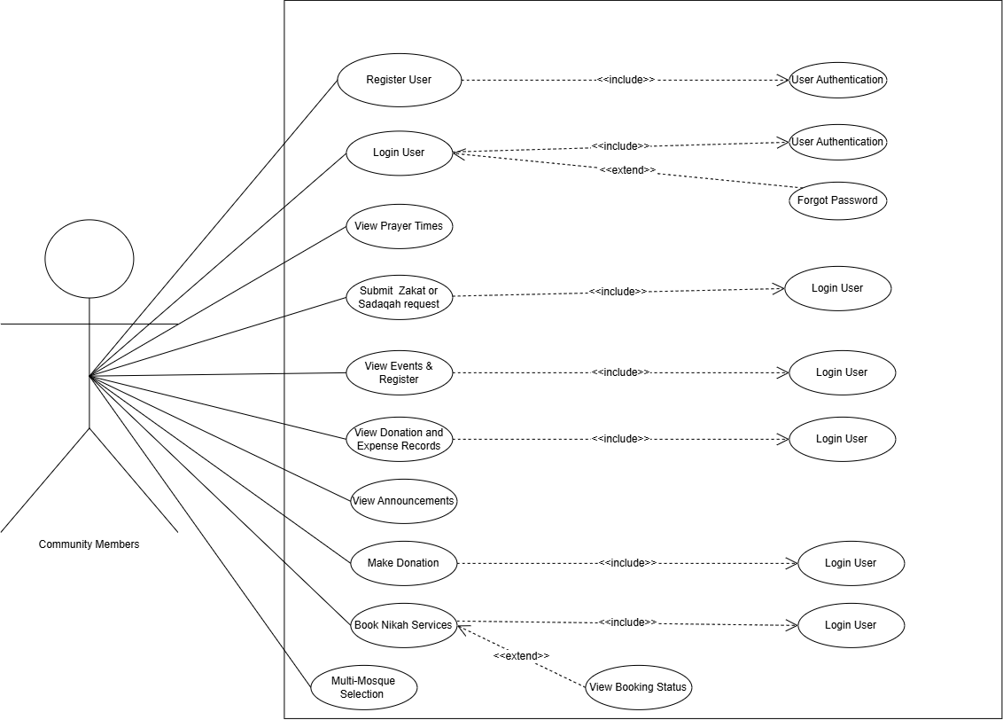
Figure 2 Use Case diagram of Community members

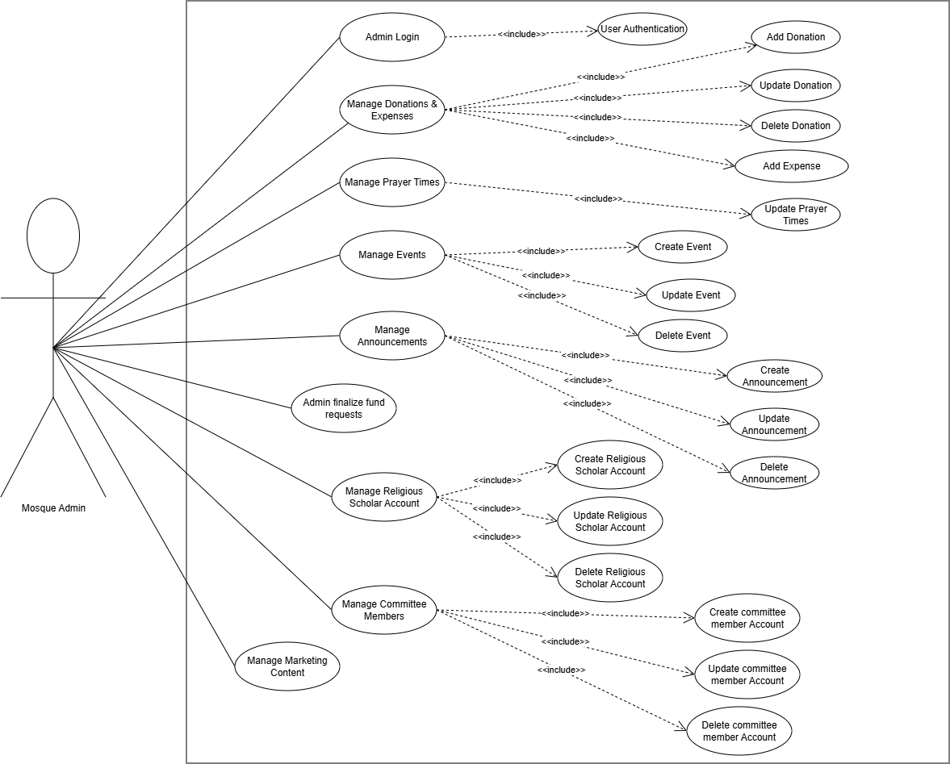
Figure 3 Use Case diagram of Mosque Admin
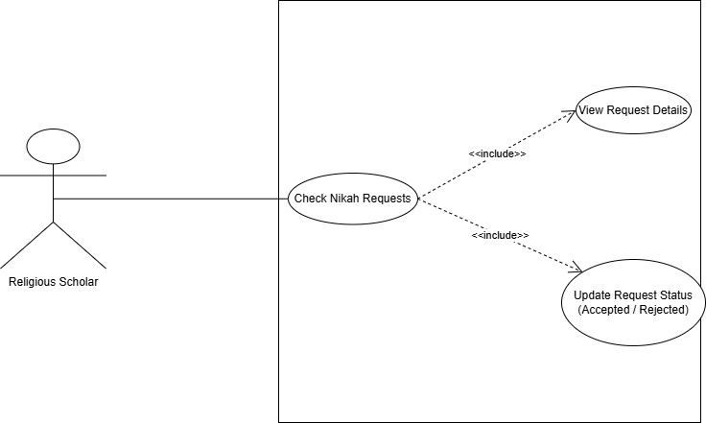
Figure 4 Use Case diagram of Religious Scholar

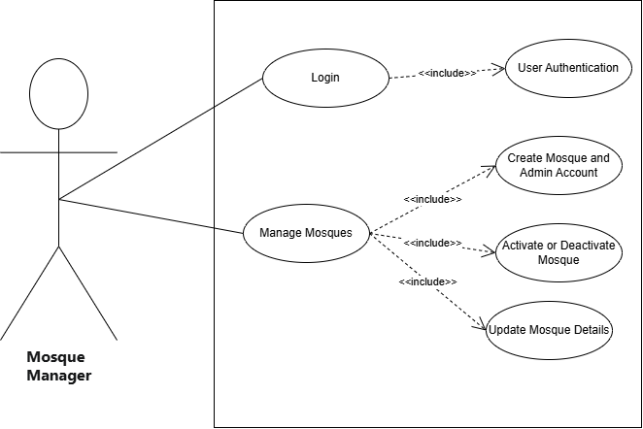
Figure 5 Use case diagram of Mosque Manager
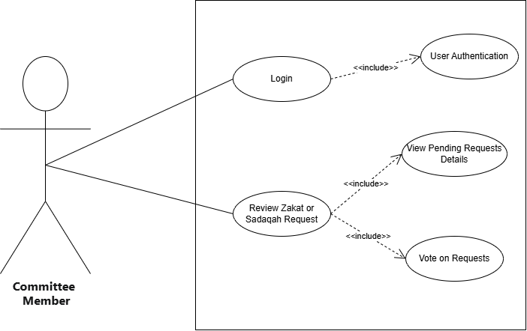

Figure 6 Use Case diagram of Committee Members

Storyboards
This section shows how users will use our system in real life. Each storyboard explains one main feature that happen on screen.

Storyboard 1 : Online Donation System
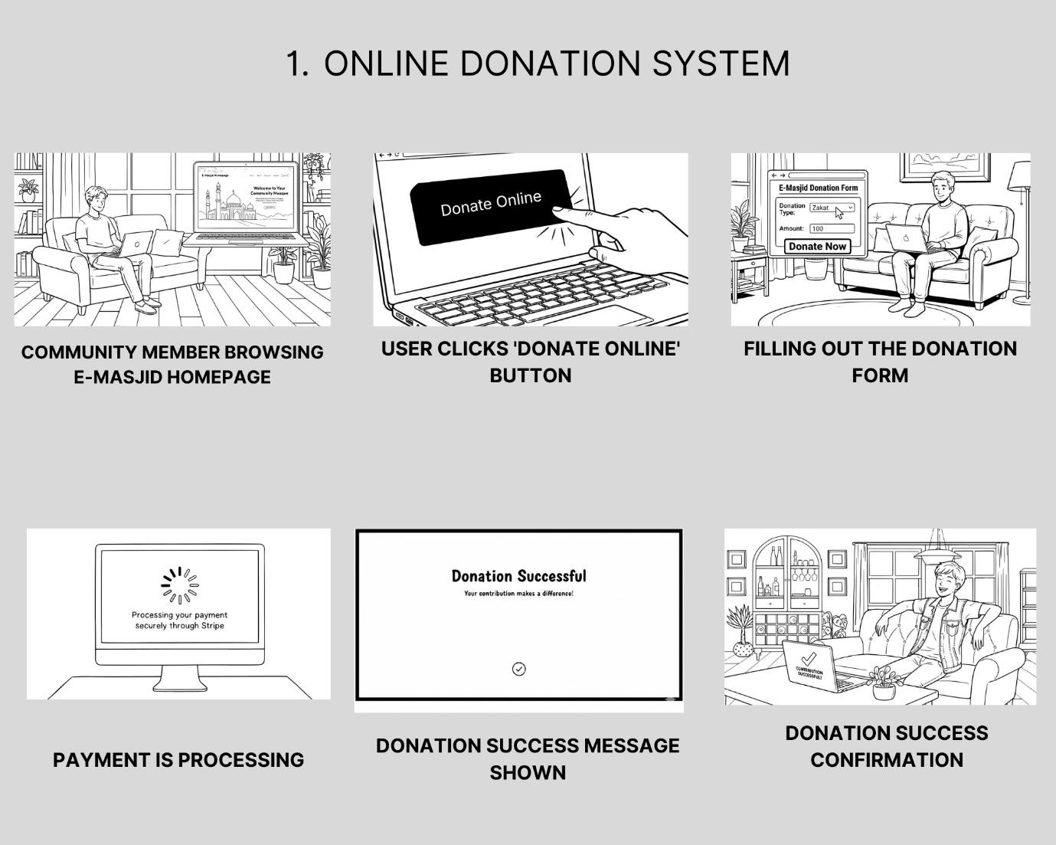
Figure 7 Online Donation Storyboard

Storyboard 2 : Event Management

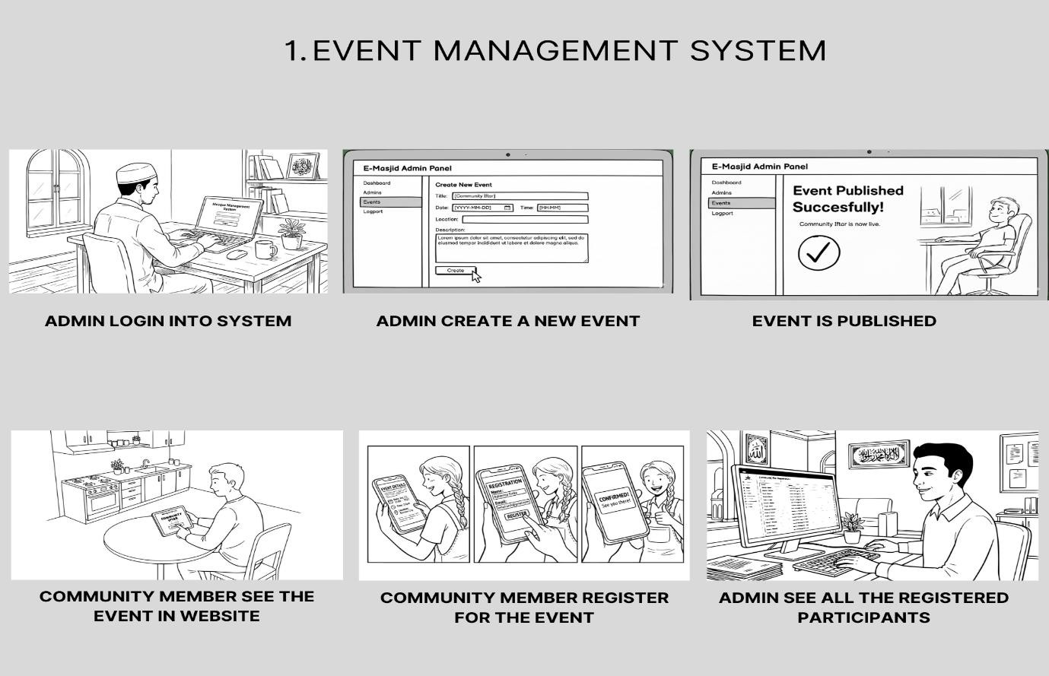
Figure 8 Event Management Storyboard

Storyboard 3 :Nikah Booking
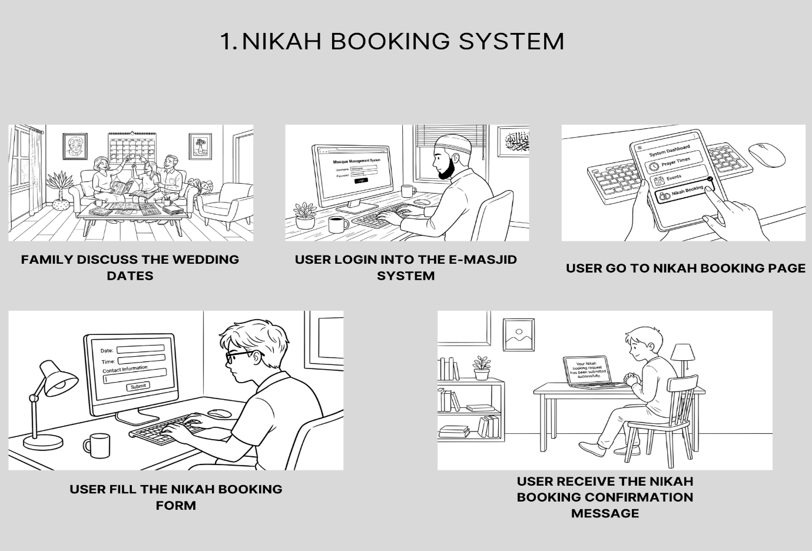
Figure 9 Nikah booking Storyboard

Summary
In this chapter, we covered the requirements of the E-Masjid System. We listed all five user classes and explained what each one can do in the system. We wrote seventeen functional requirements that cover the main features including multi-mosque management, prayer times, donations, fund requests, nikah bookings and marketing content. We also wrote non-functional requirements in four categories which are reliability, usability, performance and security. Then we covered the external interface requirements for user interface, software, hardware and communication. We wrote 24 use cases that explain how each user interacts with the system for every important task. We also drew use case diagrams for all five actors. These requirements give a clear picture of what the system should do and how it should behave.

Chapter 3
Design and Architecture

System Design
Our E-Masjid System is a web based platform built with the MERN stack. It is accessible through any modern web browser. The system is used by mosque administrators for managing operations and by community members for accessing mosque services like prayer times, donations and nikah bookings.

Dependencies
- Stable internet connection for all users.
- Stripe service availability for payment processing.
- Modern web browsers supporting React.js features.
- MongoDB database server for data storage.
- Node.js runtime for backend

Interaction with Other Systems
- Stripe Payment Gateway: It is used for making online donations securely.
- Resend Email Service: It is used for sending password reset links and fund request notifications to committee members.
- Multer: It is used for image uploads.

Design Constraints
- Performance Requirements: Prayer times page loads within 3 seconds, handles 100+ users during Friday prayers.
- Usability Requirements: Simple interface with large buttons, works on mobile and computer, elderly friendly design.
- Security Requirements: Encrypted passwords using bcryptjs, secure payments through Stripe Checkout, admin access protection.
- Technical Constraints: MERN stack technology, responsive design.

Design considerations

Assumptions
Following are the assumptions:
- Mosque administrators have basic computer knowledge.
- Users have internet access and email accounts.
- The mosque has at least one computer for admin use.
- Religious scholars can use basic web applications.
- Community members can use web browsers on phones or computers.
- The Mosque Manager is a responsible person who knows which masjids to give access to.
- Community members who submit zakat requests will give correct and honest information.
- Committee members have email addresses and can check them regularly.

Dependencies
Following are the dependencies:
- Stable internet connection for all users.
- Stripe payment service available at any time.
- Web browsers supporting modern JavaScript.
- MongoDB database running properly.
- Nodemailer library and a working Resend email service for sending committee notifications and password reset emails.

Limitations
Following are the limitations:
- Cannot work without internet connection.
- No SMS notifications for announcements.
- No mobile app version.
- Payment system requires card payments only.
- Cannot handle offline data entry.
- The system does not automatically verify the identity of fund requesters and the committee must do that manually.

Risks
Following are the risks:
- Stripe API outage or compromise could affect online donations
- System downtime during prayer times.
- Elderly users finding the system difficult.
- Data loss from system crashes

Design Models
In this section, we show how we designed the E-Masjid System. We made different diagrams to explain the system structure, how data is organized, and how different parts of the system work together. These pictures make the design easy to understand for everyone.

Design Class Diagram

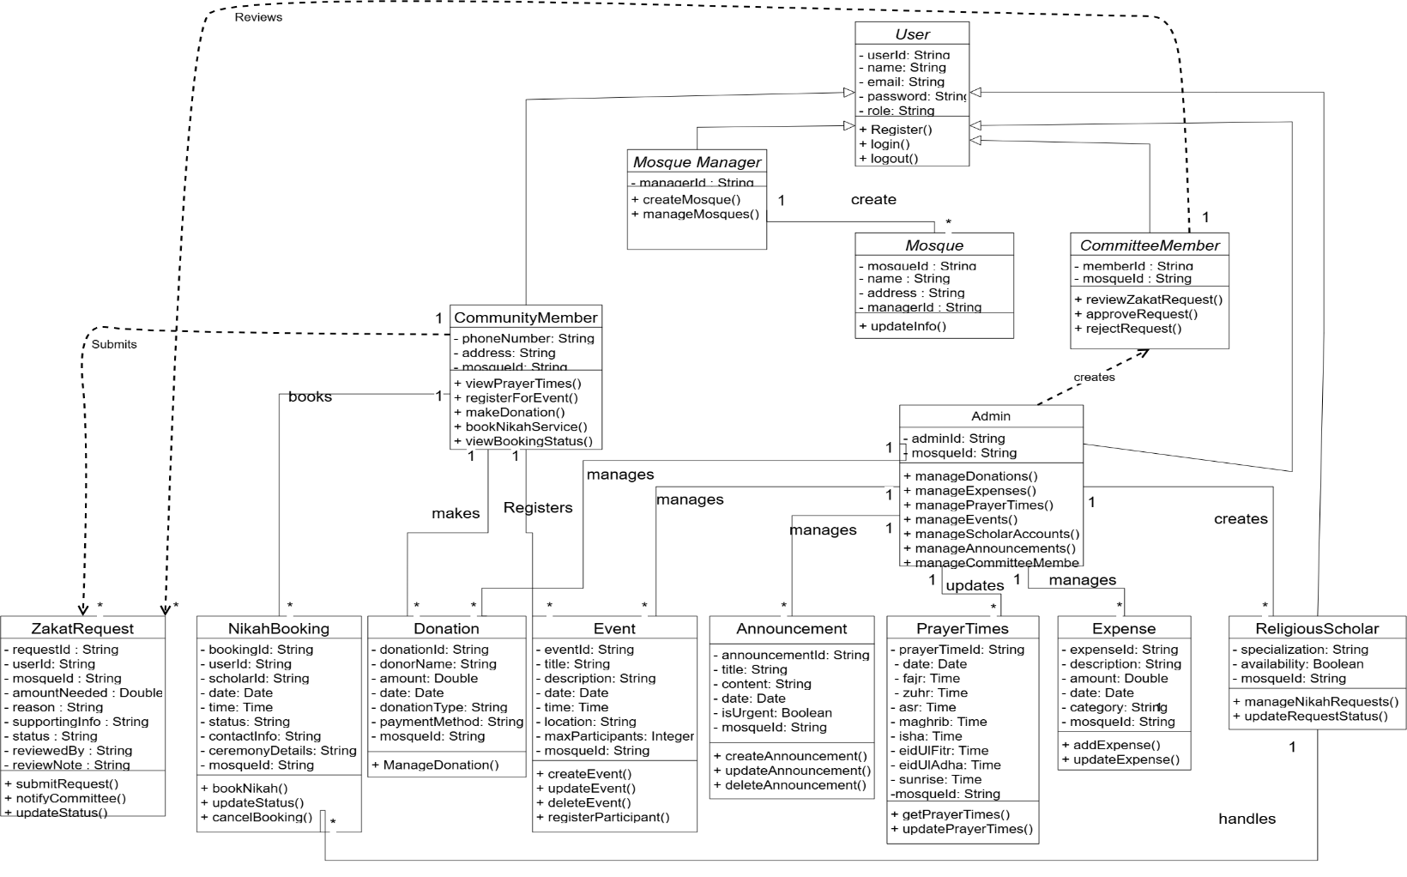
Figure 10 Class Diagram

Sequence Diagram
User Login Sequence Diagram
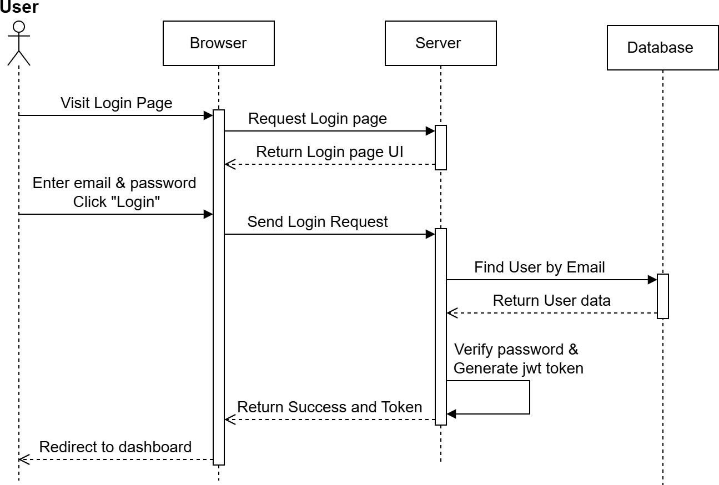
Figure 11 Login Sequence Diagram
Online Donation Sequence Diagram
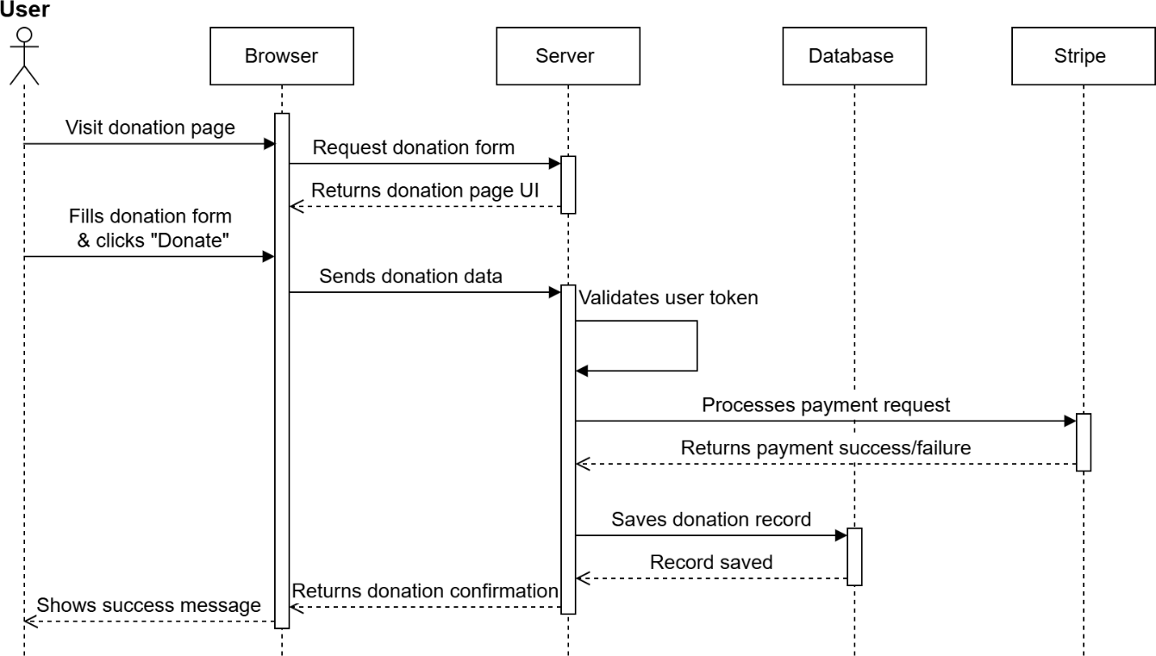
Figure 12 Online Donation Sequence Diagram

Nikah Booking Sequence Diagram
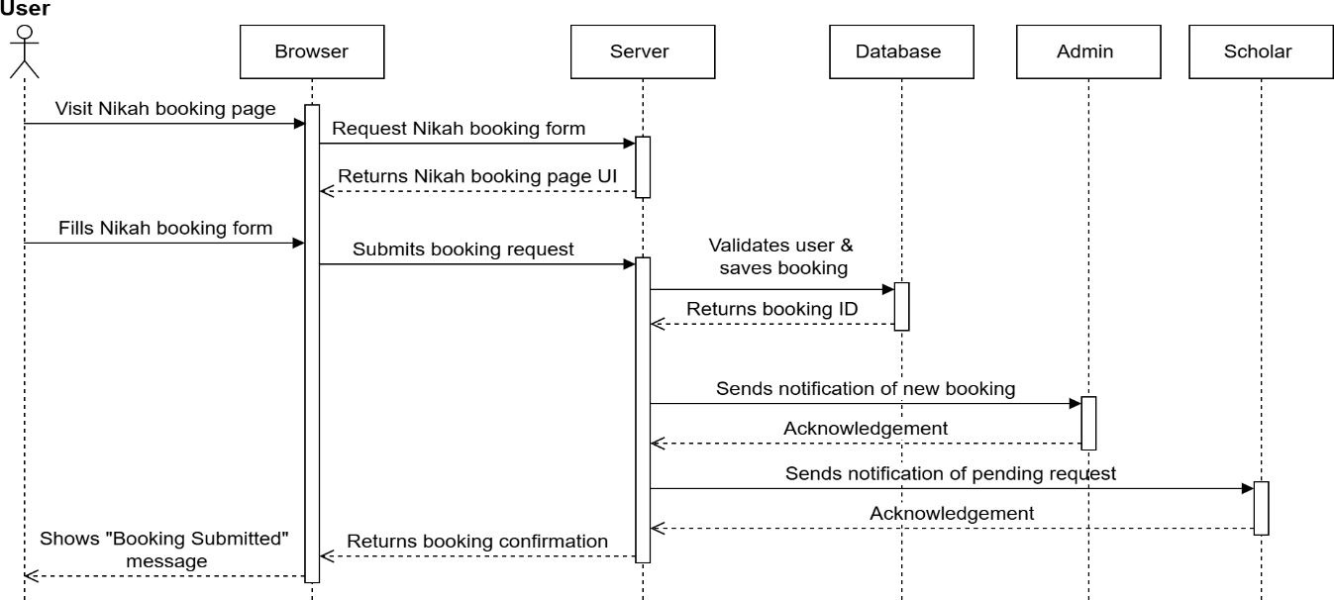
Figure 13 Nikah Booking Sequence Diagram

Prayer Times Update Sequence Diagram
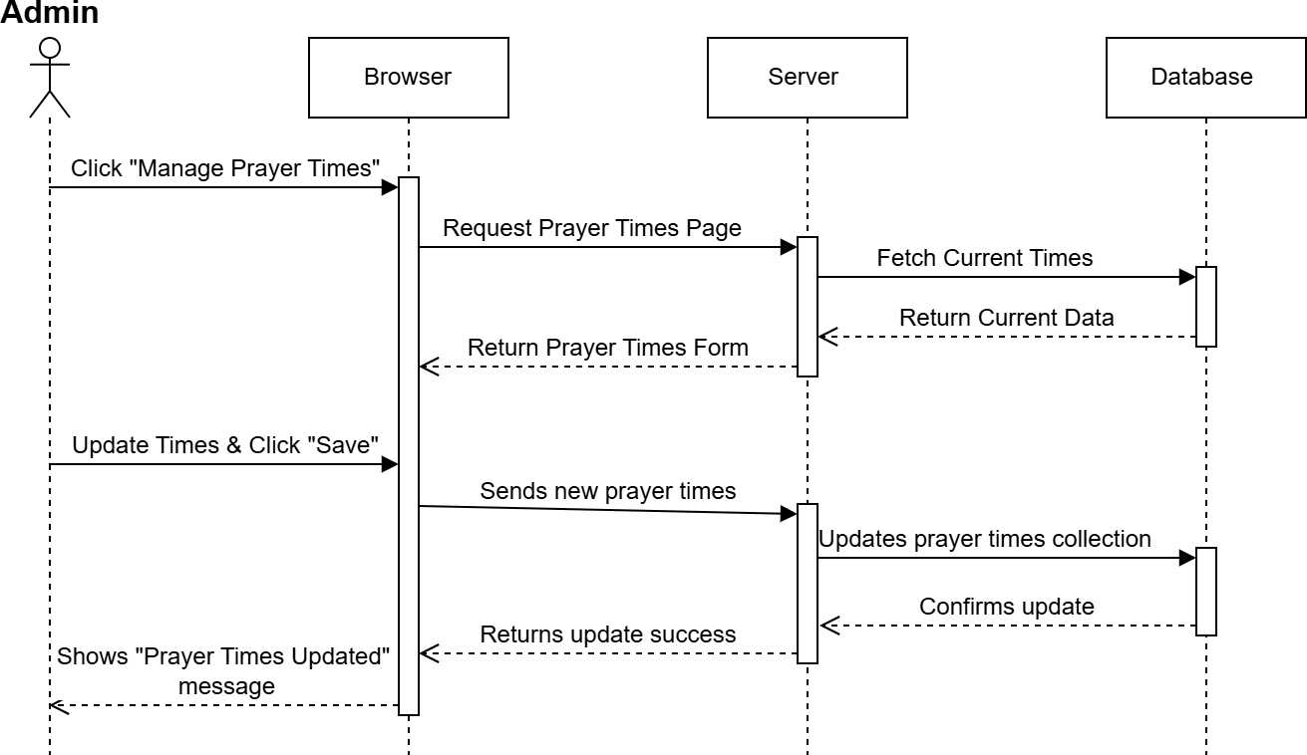
Figure 14 Admin Update Prayer Times Sequence Diagram

State Transition Diagram
These diagrams show how the system status changes when a user performs different actions.

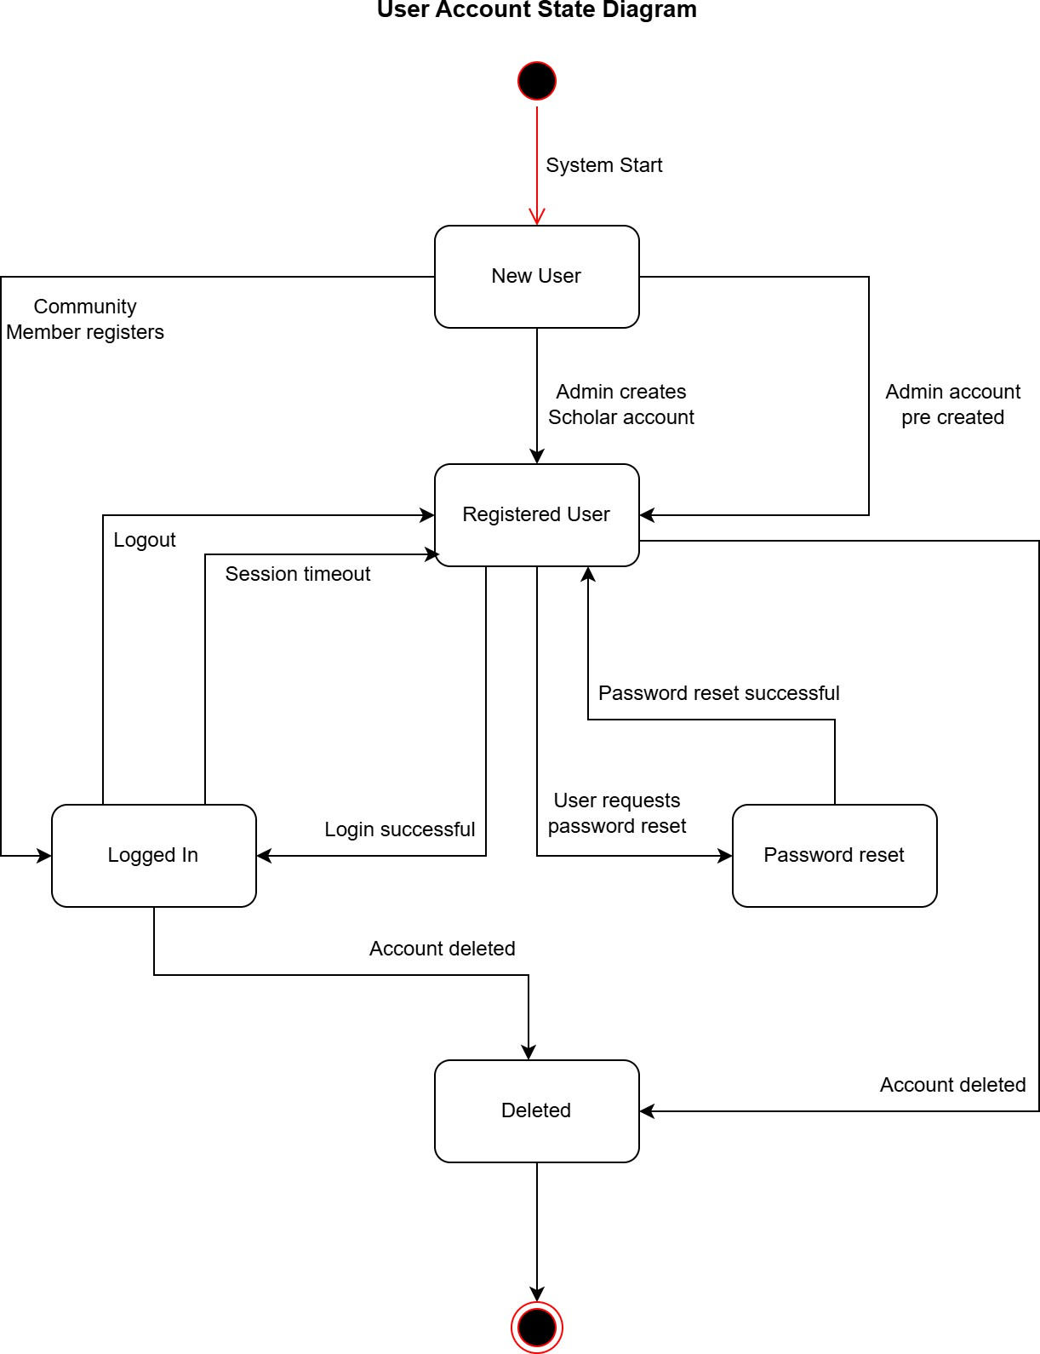
Figure 15 User Account State Diagram

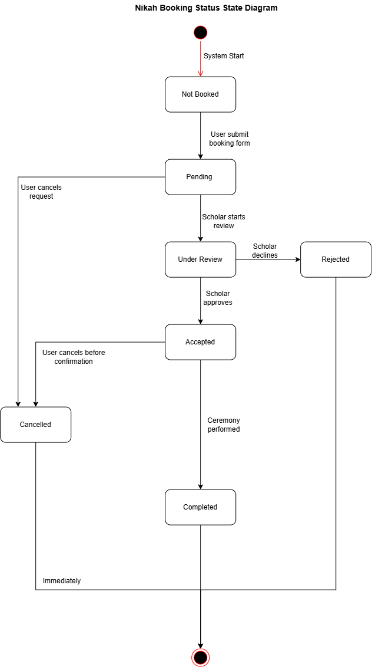
Figure 16 Nikah Booking Status State Diagram

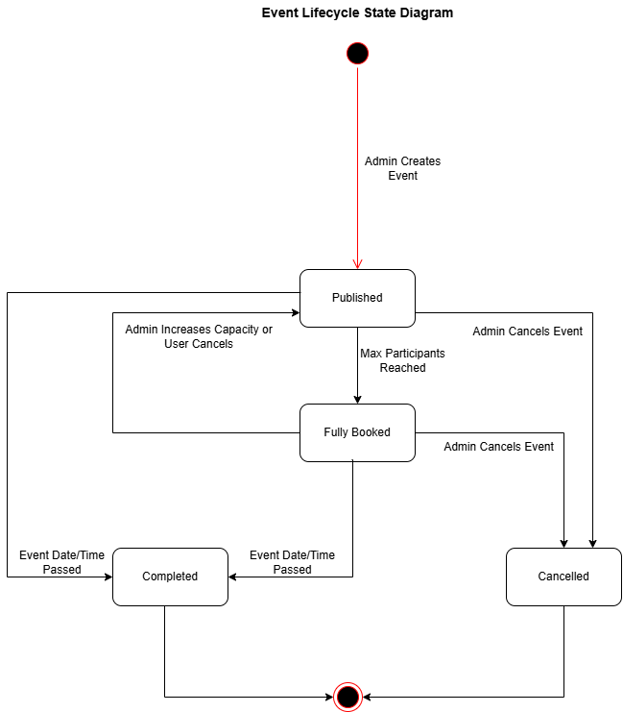

Figure 17 Event State Diagram

Architectural Design
Our E-Masjid System follows the MVC architecture pattern with a Service layer for business logic. This separates the system into three main parts.
- Model: Handles data.
- View: User interface that users see.
- Controller: Processes user requests and connects Model and View.

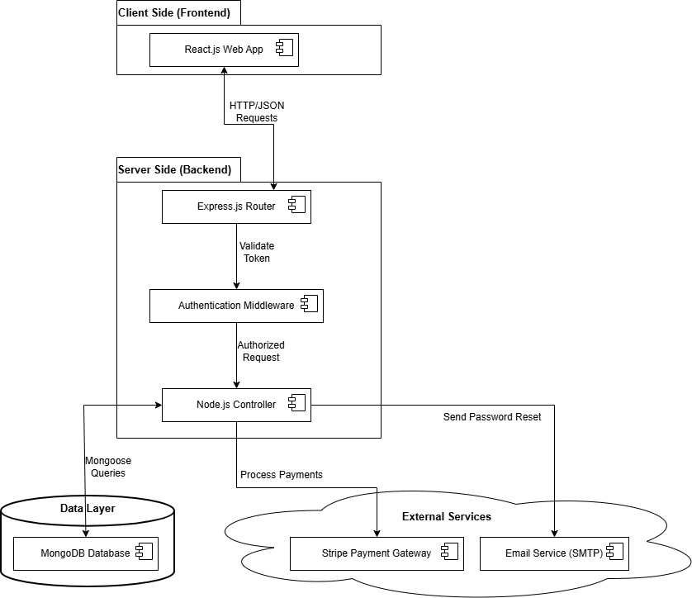
Figure 18 Architectural diagram

UML Component diagram
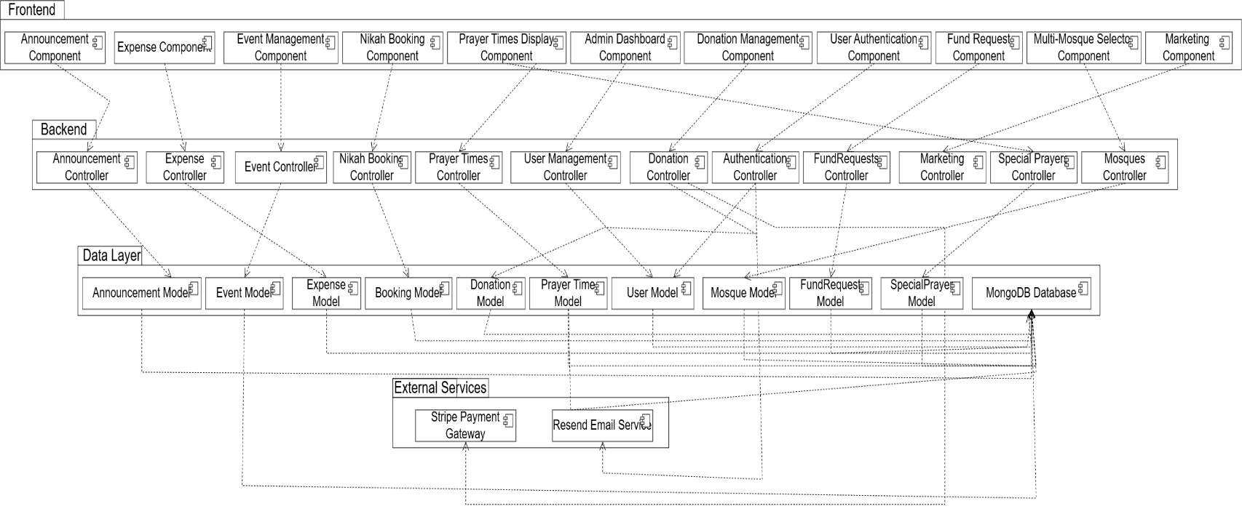
Figure 19 Component diagram

Data Design
Our system uses MongoDB database to store information. We have separate collections for different things like users, donations, events etc. Each collection keeps related information together. Admin and religious scholars are both in the users collection, with different role values.

Database Collections Structure:
- Users Collection
  - Stores all user information including admin, community members, and religious scholars.
  - Uses role based access control.
  - Fields: userId, mosqueId ,name, email, password, role, phone, address, specialization, createdAt, updatedAt.

Donations Collection
  - Records all donation transactions.
  - Links to donor information for transparency.
  - Fields: donationId, donorId, mosqueId ,amount, date, type , paymentMethod, status, stripeSessionId, anonymous.

Expenses Collection
  - Tracks mosque expenditure for financial transparency.
  - Categorized expenses for better reporting.
  - Fields: expenseId, mosqueId ,description, recordedBy, amount, date, category.

Events Collection
  - Manages mosque events and programs.
  - Supports online registration.
  - Fields: eventId, mosqueId , title, description, date, time, location, maxParticipants, registeredUsers[ ], image , requiresRegistration, isActive, createdBy.

Announcements Collection
  - Stores important mosque announcements.
  - Supports urgent flag for important updates.
  - Fields: announcementId, mosqueId ,title, content, date, isUrgent, publishedBy, createdBy.

Prayer Times Collection
  - Stores daily prayer schedules.
  - Special entries for Jummah and Ramadan.
  - Fields: prayerTimeId, mosqueId ,date, fajr, zuhr, asr, maghrib, isha, eidUlFitr, eidUlAdha, sunrise

Nikah Bookings Collection
  - Manages nikah service requests
  - Tracks booking status.
  - Fields: bookingId, userId, scholarId, mosqueId , groomName, brideName, contactPhone, date, time, status, contactInfo, ceremonyDetails.

Mosques Collection
  - Manages different mosques
  - Fields: mosqueId, name, location, contactPerson, adminUserId, createdBy.

ZakatRequests Collection
  - Manage zakat fund requests
  - Fields: requestId, userId , mosqueId, requesterName, phone, reason, amount, status, reviewedBy, reviewNote, createdAt, updatedAt.

SpecialPrayers Collection
- Manages 8 special prayer types for Eid, Ramadan, Shab events, Janazah and Milad.
- Each prayer has its own date, time and location.
- Fields: specialPrayerId, mosqueId, type,date, time, location, description, createdBy, createdAt, updatedAt.

Campaigns Collection
- Stores fundraising campaigns shown on homepage.
- Tracks campaign goal and current amount raised.
- Fields: campaignId, mosqueId, title, description, goalAmount, raisedAmount, image, isFeatured, isActive, createdBy, createdAt, updatedAt.

HeroSlides Collection
- Stores homepage hero slider images and text.
- Admin can add multiple slides that rotate on homepage.
- Fields: heroSlideId, mosqueId, title, subtitle, image, ctaText, ctaLink, order, isActive, createdBy, createdAt, updatedAt.

Data Relationships:
- One-to-many: One user can make multiple donations.
- One-to-many: One Manager can create multiple mosques
- One-to-many: One admin can create multiple events.
- Many-to-many: Many users can register for many events.
- One-to-one: Each day has one prayer time schedule.

Data Dictionary

Table 46 Data Dictionary

Terminology | Description
Users Collection | Stores all system user accounts
userId | String, Primary key for user identification
Name | String, Full name of the user
Email | String, User email address
Password | String, Encrypted password for security
Role | String, User role (admin/community/scholar/manager/committee)
Phone | String, Contact phone number.
Address | String, User residential address
Specialization | String, For scholars area of expertise
mosqueId | String, Reference to mosque
Donations Collection | Records all financial donations
donationId | String, Unique donation identifier
donorId | String, Reference to user who donated
Amount | Number, Donation amount in rupees
Date | Date, When donation was made
Type | String, Donation type (Zakat/Sadaqah/Mosque Fund)
paymentMethod | String, Cash or online payment
mosqueId | String, Reference to mosque
Expenses Collection | Tracks mosque spending
expenseId | String, Unique expense identifier
Description | String, Where the money was spent on
Amount | Number, Expense amount in rupees
Date | Date, When fund is spent
Category | String, Expense category
mosqueId | String, Reference to mosque
Events Collection | Manages mosque events
eventId | String, Unique event identifier
Title | String, Event name/title
Description | String, Detailed event information
Date | Date, Event date
Time | Time, Event time
Location | String, Where event will be held
maxParticipants | Number, Maximum allowed attendees
registeredUsers | Array, List of user IDs who registered
mosqueId | String, Reference to mosque
Announcements Collection | Stores mosque announcements
announcementId | String, Unique announcement identifier
Title | String, Announcement headline
Content | String, Full announcement text
Date | Date, When announcement was posted
isUrgent | Boolean, Marks urgent announcements
publishedBy | String, Admin who posted the announcement
mosqueId | String, Reference to mosque
PrayerTimes Collection | Stores prayer schedules
prayerTimeId | String, Unique prayer time identifier
Date | Date, Date for prayer times
Fajr | Time, Fajr prayer time
Zuhr | Time, Zuhr prayer time
Asr | Time, Asr prayer time
Maghrib | Time, Maghrib prayer time
Isha | Time, Isha prayer time
eidUlFitr | Time, Eid-ul-Fitr prayer time
eidUlAdha | Time, Eid-ul-Adha prayer time
sunrise | Time, Sunrise time
mosqueId | String, Reference to mosque
NikahBookings Collection | Manages marriage service requests
bookingId | String, Unique booking identifier
userId | String, Reference to user who booked
scholarId | String, Reference to assigned scholar
Date | Date, Requested ceremony date
Time | Time, Requested ceremony time
Status | String, Current status (Pending/Accepted/Rejected)
contactInfo | String, User contact details for ceremony
ceremonyDetails | String, Additional ceremony information
mosqueId | String, Reference to mosque
Mosques Collection | Stores details of each mosque registered in the system.
mosqueId | String, unique identifier for the mosque.
name | String, store name of mosque
Location | String, store address of mosque
contactPerson, | String, store contact information
adminUserId | String, store unique admin id
createdBy | String, store created date of mosque
ZakatRequests Collection | Stores all Zakat and Sadaqah help requests.
requestId | String, unique request identifier.
userId | String, reference to the user who submitted the request.
mosqueId | String, Reference to mosque
requesterName | String, user name who is requesting
phone | String, user phone no
reason | String, reason of the fund request
status | String, reference to Pending, Approved, Rejected.
reviewNote | String, user ID of the committee member who took the decision.
reviewComment | String, reason given by the committee.
SpecialPrayers Collection | Store the special prayer times data
specialPrayerId | String , unique request identifier.
mosqueId | String, Reference to mosque
type | String, type of the prayer
date | Date, date of the special prayer
location | String, location where the prayer will be held
description | String, description of the prayer
Campaigns Collection | Store all the campaigns data
campaignId | String, unique request identifier.
mosqueId | String , Reference to mosque
title | String, title of the campaign
description | String, description of the campaign
goalAmount | Number, Target amount need to raise
raisedAmount | Number, Amount that has been collected yet.
image | String, File path of uploaded campaign image
isFeatured, | Boolean, Whether campaign is featured on homepage
isActive, | Boolean, Whether campaign is currently active
HeroSlides Collection
heroSlideId | String, Unique identifier for the hero slide
mosqueId | String, Reference to mosque
title | String, Main heading text shown on the slide
subtitle | String, Supporting text shown below the title
image | String, File path of uploaded slide background image
ctaText | String, Call-to-action button label
ctaLink | String, URL the CTA button navigates to when clicked
order | Number, Display order of the slide in the homepage carousel
isActive | Boolean, Whether the slide is currently shown on the homepage

User Interface Design
The E-Masjid System will have a clean, simple, and easy to use interface designed for all
types of users, including elderly people who may not be comfortable with complex technology.

User Experience
- Homepage: Shows current prayer times, recent announcements, hero carousel, impact counters, testimonials, featured campaigns, hadith of the day and quick access buttons for main features.
- Navigation: Simple menu at the top with clear labels.
- Mobile Friendly: All screens work perfectly on mobile phones and tablets.
- Elderly Friendly: Large buttons, clear text, and simple forms.

How Different Users Will Use the System:

For Mosque Manager:
- Access manager panel at /manager URL.
- Manage multiple mosques
- Assign admins to specific mosques.
- View high level overview across all mosques.

For Community Members:
  - Prayer times always visible on top of home page.
  - Simple donation form with card payment option.
  - Registration button for events.
  - Easy booking form for nikah.
  - View booking status in mybooking page.
For Mosque Admin:
- Special admin panel accessible through /admin URL.
- Simple forms to add/update donations, expenses, events, announcements.
- Monthly transparency report showing total income, expenses, and net balance.
- Create and manage religious scholar accounts and committee members accounts.
- Also manage prayer times, fund requests and marketing content and finalize the fund requests.

For Religious Scholars:
- View pending requests in simple list format.
- One click buttons to accept or reject bookings.
- See their confirmed ceremonies in a list view on their dashboard.

For Committee Members:
- Access committee panel at /committee URL.
- View pending fund requests needing their vote.
- Vote approve or reject with comments.
- See voting status.

Feedback and Messages:
- Green popup messages for successful actions.
- Red popup messages with simple explanations.
- "Are you sure?" prompts for important actions.

Screen Images
We have created basic screen designs to show how the interface will look. These designs follow our guidelines of simplicity and ease of use.
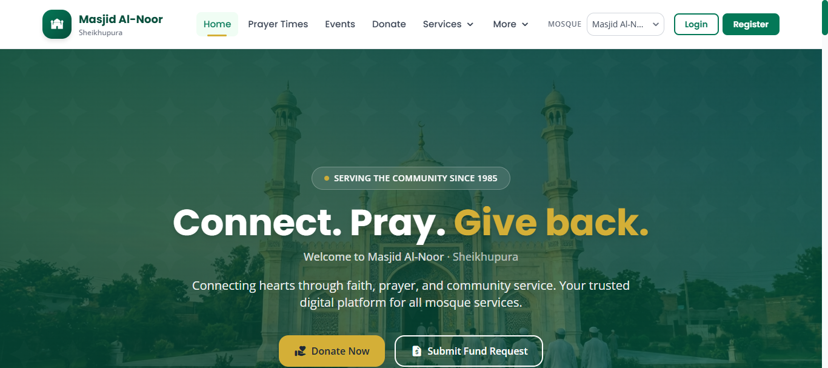
Figure 20 Hero Section design

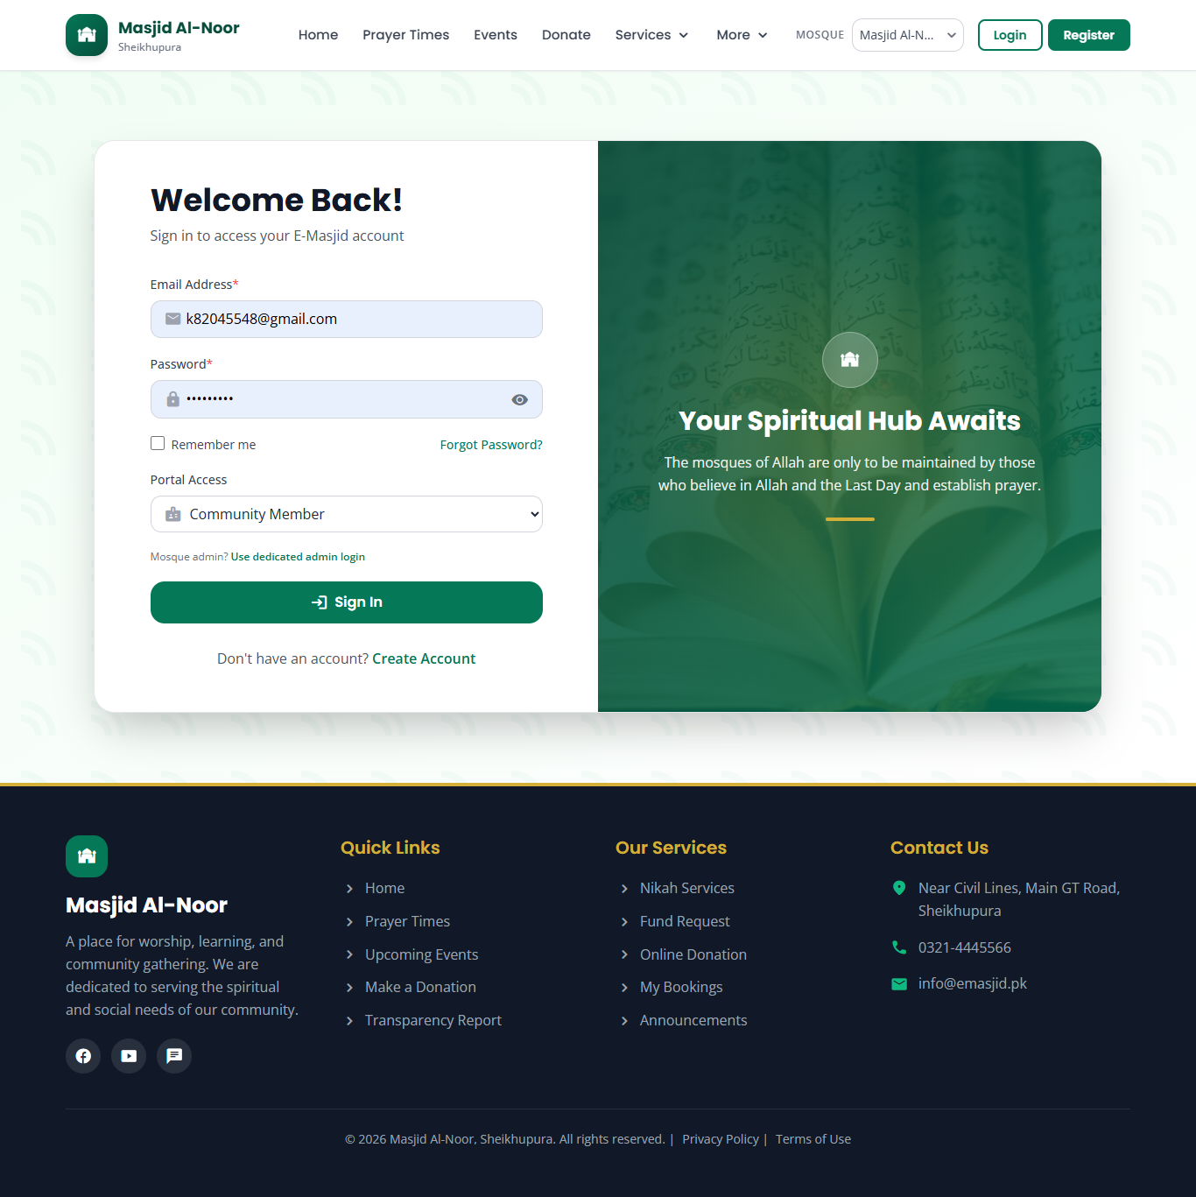
Figure 21 Login page design

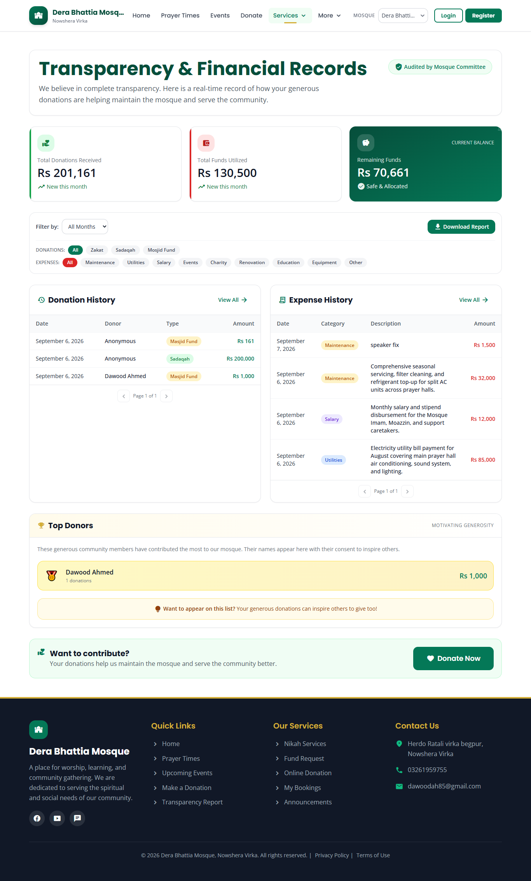
Figure 22 Donation Transparency page design

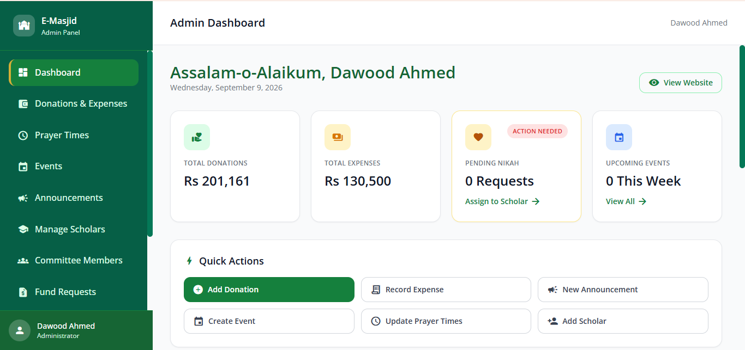
Figure 23 Admin Dashboard design
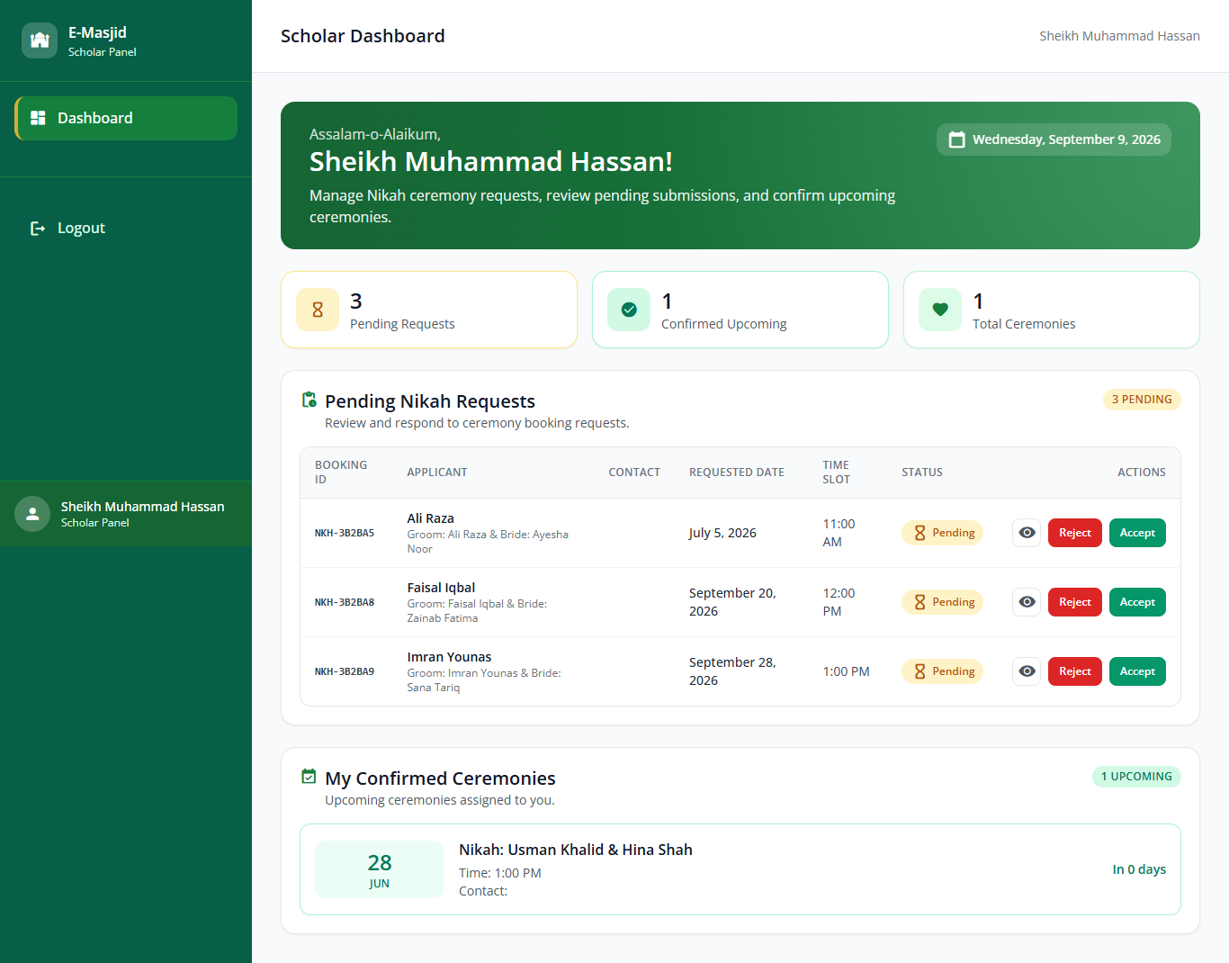
Figure 24 Scholar page design

Screen Objects and Actions

Use Case 1: Making an Online Donation Screen Objects:
      - Donation Amount Field: Text box to enter donation amount.
      - Donation Type: Select Zakat, Sadaqah, or Mosque Fund.
      - Stripe Checkout: Fields for card number, expiry, CVC.
      - Donate Now Button: Green button to submit donation.

Actions:
- User enters amount: System validates it is atleast PKR 100.
- User selects donation type: System shows description of that type.
- User selects Online payment: System redirects to Stripe Checkout for payment.
- User clicks Donate Now: System processes payment via Stripe.
- Payment successful: Shows a success card on the Donate page with the transaction ID and amount.
- Payment failed: Shows red "Payment Failed" message with retry option.

Use Case 2: Admin Creating an Event
Screen Objects:
  - Event Title Field: Text box for event name.
  - Date and Time Pickers: Calendar and time selectors.
  - Description Box: Large text area for event details.
  - Location Field: Text box for event location.
  - Max Participants Field: Number field for attendance limit.
  - Create Event Button: Blue button to publish event.

Actions:
- Admin enters event details: System validates all required fields.
- Admin sets date/time: System checks date is not in past.
- Admin sets max participants: System validates positive number.
- Admin clicks Publish: System creates event and shows on website.
- Event published: Shows green "Event created Successfully".
- Validation error: Shows red message next to incorrect field.

Use Case 3: Submitting a Fund Request Screen Objects:
- Name Field: Text box for requester name
- Phone Field: Phone no of the person
- Reason Field: large area text
- Amount Needed Field: Number box for amount
- Submit Button: submit the request

Actions:
- User enters details: System checks that all fields are filled.
- User clicks Submit: System saves request, sends emails to committee and shows a "Request Submitted" message.
- If any field is empty, a red message appears: "Please fill all fields."

Design Decisions
This section explains the main design choices we made for the E-Masjid System and why we chose them.
We decided to use the MVC pattern with a Service layer. This means we separate our code into four main parts: Model handles data, View is the user interface, Controller processes user requests, and the Service layer holds the business logic.
We chose the MERN stack because the same JavaScript language is used in the frontend, backend and database layer. This removes the need to switch between different languages and makes the code easier to maintain.
We picked MongoDB instead of traditional SQL databases because it works naturally with JavaScript and Node.js.
We chose Stripe for online donations because it handles all card details on Stripe own secure page, which means we never store card numbers on our server.
We plan to deploy the system on cloud services because it is more reliable than our own computers and can handle more users during busy times.

Summary
This Software Design Specification shows the technical plan for our E-Masjid System. The chapter started with the class diagram showing the main entities and their relationships, including the five user roles, the Mosque, and core data models like Donation, Expense, Event, and Announcement. We then explained the MVC architecture with a Service layer, the MERN stack, the component diagram and the data design with twelve MongoDB collections using a mosqueId field for multi-tenant data separation. The user interface design and design decisions sections described how each role will use the system and why we picked each technology. This design provides a clear technical foundation for the implementation phase, which is covered in the next chapter.

Chapter 4 Implementation

Implementation

Algorithm

Table 47 Record Donation Algorithm

Algorithm 1 Record Donation
Input: donorName,email,phone, amount, type, isAnonymous, paymentMethod,mosqueId
Output: donation record saved or error
1: Validate amount > 100 PKR, type not empty
2: If validation fails, return error "Invalid input"
3: Create donation object:
donorName = donorName
email = email
phone = phone
amount = amount
type = type
paymentMethod = paymentMethod
isAnonymous = isAnonymous
mosqueId = mosqueId
createdAt = current date
4: If paymentMethod = "Online":
Create Stripe Checkout session using stripe.checkout.sessions.create
Set success_url and cancel_url
Save donation in Donations collection with status = "pending"
Return Stripe Checkout URL to client
5: Else:
Save donation in Donations collection with status = "completed"
6: If save fails, return error "Could not save donation"
7: Return success message "Donation recorded"

Table 48 Submit Zakat Request Algorithm

Algorithm 2 Submit Zakat Request
Input: userId, requesterName, requesterEmail, requesterPhone, reason, amount, category, mosqueId
Output: request saved, emails sent to committee members
1: Check all required fields are filled
2: Validate reason has at least 30 characters
3: Validate amount is between 1 and 10,000,000 PKR
4: Validate category
5: If any validation fails, return error with specific message
6: Create request object:
requesterName = requesterName
requesterEmail = requesterEmail
requesterPhone = requesterPhone
reason = reason
amount = amount
category = category
userId = userId
mosqueId = mosqueId
status = "pending"
votes = empty array
createdAt = current date
7: Save request in FundRequests collection
8: If save fails, return error "Could not submit request"
9: Find all users with role="committee", isActive=true, and same mosqueId
10: For each committee member, get their email
11: Use Nodemailer to send email with request details to each email
12: Return success message "Request submitted. Committee will vote and admin will finalize."

Table 49 Committee Review Decision Algorithm

Algorithm 3 Committee Review Decision
Input: requestId, committeeUserId, vote, note
Output: vote added to request votes array, status stays "pending"
1: Validate vote is one of ("approve", "reject")
2: If validation fails, return error "vote must be approve or reject"
3: Find request by requestId where status="pending" and mosqueId matches
4: If request not found, return error "Request not found or already finalized"
5: Create vote object:
member = committeeUserId
vote = vote
note = note
votedAt = current date
6: Filter out any existing vote by the same committee member from votes array
7: Append new vote to votes array (atomic update using $concatArrays)
8: Save updated request
9: If save fails, return error "Could not save vote"
10: Return success message "Vote recorded. Admin will finalize the request."
Table 50 Admin Finalize Fund Request Algorithm

Algorithm 4 Admin Finalize Fund Request
Input: requestId, adminUserId, finalNote
Output: request status set to approved or rejected, requester notified by email
1: Validate requestId is a valid ObjectId
2: If invalid, return error "Invalid request id"
3: Verify caller has role="admin"
4: If not admin, return error "Only admin can finalize a fund request"
5: Find request by requestId in FundRequests collection
6: If not found, return error "Request not found"
7: If request.mosqueId does not match admin's mosqueId, return error "Not authorized"
8: If request.status is not "pending", return error "Request is already finalized"
9: Count votes: approve = count of votes where vote="approve", reject = count where vote="reject"
10: If total votes is 0, return error "No committee votes recorded yet"
11: If approve > reject, set status = "approved"
12: Else if reject > approve, set status = "rejected"
13: Else (tied):
If admin provided overrideStatus ("approved" or "rejected"), use it
Else return error "Votes are tied; admin must provide overrideStatus"
14: Update request:
status = status (approved or rejected)
finalizedBy = adminUserId
finalizedAt = current date
finalNote = finalNote
15: Save updated request
16: If save fails, return error "Could not finalize request"
17: Send email to requester with:
Status
Final note from admin
Category and amount for reference
18: Return success message "Request finalized. Requester has been notified."
Table 51 Process Online Donation Algorithm

Algorithm 5 Process Online Donation
Input: donorName, email, phone, amount, type, isAnonymous, mosqueId
Output: Stripe Checkout URL for redirect
1: Validate amount >= 100 PKR and type is one of Sadaqah, Zakat and Masjid Fund
2: If validation fails, return error "Invalid input"
3: Create pending donation in Donations with status="pending" and paymentMethod="Online"
4: Call Stripe API: stripe.checkout.sessions.create with success_url and cancel_url
5: Save returned session.id as stripeSessionId
6: Return Stripe Checkout URL to client
Table 52 User Login Algorithm

Algorithm 6 User Login
Input: User Login
Output: JWT token in httpOnly cookie, user data
1: Find user by email in Users collection
2: If user not found, return error "Invalid credentials"
3: Compare password with stored hash using bcrypt.compare
4: If password does not match, return error "Invalid credentials"
5: If user.isActive is false, return error "Account is deactivated"
6: Generate JWT token and set httpOnly cookie "emasjid_token" with maxAge 8 hours
7: Return success with user data

Table 53 User Register Algorithm

Algorithm 7 User Register
Input: name, email, password, phone, address, city, mosqueId
Output: new user created, JWT token in httpOnly cookie
1: Validate password matches regex
2: Check if email already exists in Users collection
3: If mosqueId provided, verify mosque exists and isActive=true
4: Hash password using bcrypt with 10 salt rounds and create user with role="community"
5: Generate JWT token and set httpOnly cookie "emasjid_token" with maxAge 8 hours
6: Return success with new user data

External APIs/SDKs

Table 44 Details of APIs used in the project

Name of API and version | Description of API | Purpose of usage | List down the API endpoint/function/class in which it is used
Stripe API | Online payment processing | Secure online donations via card | stripe.checkout.sessions.create()
Resend API | For sending emails | To send email for forgot password and committee member and email verification code. | nodemailer.createTransport({ host: 'smtp.resend.com', port: 465, secure: true, auth: { user: 'resend', pass: RESEND_API_KEY } })

Code Repository
In order to manage the version control and collaboration effectively for the group project, Git will be used as the primary tool. All project files, including code, documentation, and other relevant resources, will be stored in the Git repository. This will ensure proper tracking of changes, collaboration among team members, and access to the most up-to-date version of the project.

Git Repository Link:
The repository for the group project can be accessed using the following link:
[https://github.com/dawood125/E-Masjid-System]

    - Metrics of the Git Repository: The following metrics will be monitored to ensure effective use of the Git repository:
Commits: The number of commits made to track the frequency and consistency of contributions by team members.
Branches: The number of active and merged branches, representing the organization of different stages of development.
Pull Requests: The number of pull requests created, merged, or in review, showing the collaboration and code review process.
Contributors: A list of contributors and their contribution statistics (commits, lines added, and lines removed).
Code Reviews: The number of reviews conducted on pull requests to ensure code quality and compliance with project standards.

Summary
In this chapter, we described the main algorithms used in the system. We listed the external APIs that the project depends on. The code is managed through a Git repository with proper branching and pull request practices. All major features have been implemented according to the design and the system is ready for testing and deployment.

Chapter 5
Testing and Evaluation

Introduction
Testing is important to make sure our system works correctly and does what we promised in the requirements. We tested the E-Masjid System in four ways: unit testing for small parts, functional testing for full features, integration testing to check how parts work together, and performance testing for speed and stability. Below are the test cases we ran. We followed the testing best practices given in the template.

Unit Testing (UT)
We tested individual backend functions to make sure they work properly on their own.
Table 54 Testcase User Registration

Field | Value
Testcase ID | UT-1
Requirement ID | FR-1
Title | User Registration
Description | Check if a new user can register with correct details
Objective | Make sure the registration function hashes the password, saves the user and returns a token
Driver/precondition | Server running, database empty of this user
Test steps | 1. Send POST /api/auth/register with name, email, password, phone  2. Check response status and body  3. Check that password is hashed in Users collection  4. Check that JWT token is set in httpOnly cookie
Input | name: "Ahmed", email: "ahmed@test.com", password: "ahmed123", phone: "03001234567"
Expected Results | Status 201, success: true, token returned, user saved with hashed password
Actual Result | Status 201, success: true, token returned, user saved in Users collection with bcrypt hashed password
Remarks | Pass

Table 55 Testcase Anonymous Donation and expense Recording

Field | Value
Testcase ID | UT-2
Requirement ID | FR-2, FR-3
Title | Record Donation with Anonymous and Record Expense
Description | Test that a donation with anonymous flag is saved with donor name masked and an expense is saved with correct category and both show in the financial summary
Objective | Make sure both donation and expense data are stored correctly and reflected in the financial reports
Driver/precondition | Database connected, donations service and expenses service loaded
Test steps | 1. Add donation in admin dashboard with isAnonymous: true  2. Check the saved donation has isAnonymous: true and donorName stored as "Ahmed"  3. verify donorName shows as "Anonymous" in transparency page  4. Add expense in admin dashboard with description, amount, category  5. Check the saved expense has all fields  6. Verify Utilities category total is PKR 12000  7. Verify both donation and expense totals match
Input | donorName: "Ahmed", amount: 500, type: "Sadaqah", paymentMethod: "Cash", isAnonymous: true, mosqueId: "..." , description: "Electricity bill for July 2026", amount: 12000, category: "Utilities", mosqueId: "...", addedBy: "..."
Expected Results | Donation saved with isAnonymous: true, expense saved with all fields
Actual Result | Donation saved with isAnonymous: true, donorName shown as "Anonymous" on public list and expense is showing properly
Remarks | Pass

Table 56 Testcase Fund Request Reason Length Validation

Field | Value
Testcase ID | UT-3
Requirement ID | FR-13
Title | Fund Request Reason Length Validation
Description | Check if the system rejects a fund request with reason less than 30 characters
Objective | Make sure reason length validation works before saving
Driver/precondition | User logged in
Test steps | 1. Send POST /api/fund-requests with reason = "short reason"  2. Check response for validation error
Input | requesterName: "Ali", requesterEmail: "ali@test.com", requesterPhone: "03001234567", amount: 1000, category: "Medical", reason: "short reason"
Expected Results | Status 400, error: "Reason should be at least 30 characters"
Actual Result | Status 400, error message: "Please provide more detail
Remarks | Pass

Table 57 Testcase Password Strength Validation
Field | Value
Testcase ID | UT-4
Requirement ID | FR-1
Title | Password Strength Validation
Description | Check if weak passwords are rejected before saving
Objective | Make sure the password regex enforces 8-64 chars with letter + digit
Driver/precondition | Server running
Test steps | 1. Send POST /api/auth/register with weak password "12345"  2. Check response
Input | name: "Test", email: "test@test.com", password: "12345"
Expected Results | Status 400, error: "Password must be 8-64 chars with letter and digit"
Actual Result | Status 400, error message: "Password must be 8-64 chars and include at least one letter and one number"
Remarks | Pass
Table 58 Testcase Donation Type Validation

Field | Value
Testcase ID | UT-5
Requirement ID | FR-2
Title | Donation Type Validation
Description | Check if invalid donation types are rejected
Objective | Make sure only Sadaqah, Zakat, Masjid Fund are accepted
Driver/precondition | User logged in
Test steps | 1. Send POST /api/donations/cash with type: "Haram"  2. Check response
Input | donorName: "Ahmed", amount: 500, type: "Haram", paymentMethod: "Cash", mosqueId: "..."
Expected Results | Status 400, error: "Type must be Sadaqah, Zakat, or Masjid Fund"
Actual Result | Status 400, error: "Invalid value for type"
Remarks | Pass
Table 59 Testcase Donation Minimum Amount Validation

Field | Value
Testcase ID | UT-6
Requirement ID | FR-2
Title | Donation Minimum Amount Validation
Description | Check if donations below PKR 100 are rejected
Objective | Make sure the minimum donation amount is enforced
Driver/precondition | User logged in
Test steps | 1. Send POST /api/donations/online with amount: 50  2. Check response
Input | donorName: "Ahmed", amount: 50, type: "Sadaqah", aymentMethod: "Online", mosqueId: "..."
Expected Results | Status 400, error: "Minimum donation amount is PKR 100"
Actual Result | Status 400, error: "Minimum donation amount is PKR 100"
Remarks | Pass

Functional Testing (FT)
We tested each module from the user's point of view, making sure the whole feature works.
Table 60 Testcase Online Donation using Stripe

Field | Value
Testcase ID | FT-1
Requirement ID | FR-8
Title | Online Donation using Stripe
Description | A logged in community member donates online with card via Stripe
Objective | Check that the payment flow works and donation is recorded
Driver/precondition | User logged in, Stripe test mode active, mosque selected
Test steps | 1. Click "Donate Now" on the Donate page  2. Select type and enter amount greater than 100  3. System redirects to Stripe Checkout page  4. Enter test card 4242 4242 4242 4242 on Stripe page  5. Complete payment on Stripe  6. Redirected back to /donate?success=1&session_id=...
Input | Amount: 1000, type: Masjid Fund, isAnonymous: false
Expected Results | Redirected to Stripe, payment completes, redirected back with success, "JazakAllah Khair!" message shown, donation appears in admin records
Actual Result | Stripe redirect works, payment completes, success message shown, donation saved in Donations collection
Remarks | Pass

Table 61 Testcase Fund Request Submission
Field | Value
Testcase ID | FT-2
Requirement ID | FR-13
Title | Fund Request Submission
Description | A community member submits a request for financial assistance
Objective | Check that request is saved and emails are sent to committee members
Driver/precondition | User logged in, at least one committee member with email exists
Test steps | 1. Click "Request Financial Assistance" on Fund Request page  2. Fill all required fields  3. Reason must be at least 30 characters  4. Check terms agreement checkbox  5. Click Submit
Input | Name: "Ali", Email: "ali@test.com", Phone: "03001234567", Category: "Medical", Amount: 5000, Reason: "Need help for father's surgery, family cannot afford it"
Expected Results | Request saved with status "pending", email sent to all committee members of this mosque
Actual Result | Request saved with status "pending", email received in committee inbox
Remarks | Pass

Table 62 Testcase Committee Vote on Fund Request

Field | Value
Testcase ID | FT-3
Requirement ID | FR-14
Title | Committee Vote on Fund Request
Description | Committee member reviews and gives vote on a pending fund request
Objective | Check that the vote is recorded in the votes array and status stays pending until admin finalizes
Driver/precondition | Committee member logged in, pending fund request exists
Test steps | - Open committee dashboard  - Click on a pending request to see details  - Click "Approve" button  - Optionally add a note  - Vote is recorded
Input | Vote: "approve", Note: "Verified, deserving case"
Expected Results | Vote added to votes array, status stays "pending", requester sees vote counts on their /my-requests page
Actual Result | Vote recorded in votes array, status "pending", requester view shows the updated count
Remarks | Pass

Table 63 Testcase Mosque Manager Creates Mosque

Field | Value
Testcase ID | FT-4
Requirement ID | FR-12
Title | Mosque Manager Adds a New Mosque
Description | Mosque Manager creates a new mosque and assigns an admin to it
Objective | Check that mosque is saved and admin account can log in and see only this mosque data
Driver/precondition | Mosque Manager logged in
Test steps | - Go to /manager/mosques page  - Click "Add New Mosque"  - Fill name, address, city, phone, email fields  - Assign an admin to this mosque  - Click Save
Input | Name: "Madina Masjid", Address: "Main Bazaar", City: "Sheikhupura", Phone: "03001234567", Email: "madina@emasjid.pk", Admin: existing or new admin user
Expected Results | Mosque saved in Mosques collection, admin can log in and see only this mosque's data
Actual Result | Mosque saved, admin can log in and access /admin dashboard with this mosque's data only
Remarks | Pass

Table 64 Testcase Homepage Marketing Sections

Field | Value
Testcase ID | FT-5
Requirement ID | FR-17
Title | Homepage Marketing Sections
Description | Check that the homepage shows hero carousel, featured campaigns and upcoming events
Objective | Make sure all marketing sections on the homepage load correctly
Driver/precondition | Admin has uploaded at least one hero slide, created at least one campaign, and created at least one event
Test steps | - Open the homepage without logging in  - Look at the hero carousel at the top  - Scroll down to see Featured Campaign section  - Scroll down to see Other Campaigns grid  - Scroll down to see Upcoming Events section
Input | None
Expected Results | Hero carousel shows images with CTA buttons, featured campaign shows progress bar, upcoming events listed with date and time
Actual Result | All sections visible and loading correctly
Remarks | Pass

Table 65 Testcase User Login
Field | Value
Testcase ID | FT-6
Requirement ID | FR-1
Title | User Login for All 5 Roles
Description | Each of the 5 user roles can log in and access their dashboard
Objective | Make sure login flow works for manager, admin, scholar, committee, and community roles
Driver/precondition | Server running, seed data loaded, all 5 test accounts exist
Test steps | 1. Open /login and select community then login then go to /home  2. Logout then open /admin/login then admin login then go to /admin/dashboard  3. Logout then open /manager/login then manager login then go to /manager/dashboard  4. Logout then open /scholar/login then scholar login and then go to /scholar/dashboard  5. Logout then open /committee/login then committee login and go to /committee/dashboard
Input | 5 different email/password pairs
Expected Results | Each role logs in successfully, redirected to their role specific dashboard, httpOnly cookie "emasjid_token" is set
Actual Result | All 5 roles log in successfully, dashboards load with correct data
Remarks | Pass
Table 66 Testcase Admin Finalizes Fund Request
Field | Value
Testcase ID | FT-7
Requirement ID | FR-15
Title | Admin Finalize Fund Request
Description | After committee voting, admin finalizes the request and requester is notified
Objective | Check that admin can finalize, status is set to approved/rejected and requester gets email
Driver/precondition | Admin logged in, fund request with votes exists
Test steps | 1. Open /admin/fund-requests  2. Click on a pending request with votes  3. Review the vote counts  4. Add final note  5. Click "Finalize"  6. Requester checks email and /my-requests page
Input | Final note: "Approved based on committee majority"
Expected Results | Status set to "approved" or "rejected", finalizedBy and finalizedAt recorded, requester receives email with outcome
Actual Result | Request finalized, status updated, requester received email, /my-requests shows new status
Remarks | Pass
Table 67 Testcase Multi tenant Data Isolation

Field | Value
Testcase ID | FT-8
Requirement ID | FR-12
Title | Multi tenant Data Isolation
Description | Admin of one mosque cannot see or modify another mosque data
Objective | Make sure each admin only sees their own mosque's donations, events, fund requests, etc.
Driver/precondition | Two mosques seeded, both have admins
Test steps | 1. Login as Al-Noor admin  2. Open /admin/donations, /admin/events, /admin/fund-requests  3. Verify only Al-Noor rows are visible  4. Logout  5. Login as Al-Rahman admin  6. Open same pages, verify only Al-Rahman rows visible
Input | None
Expected Results | Each admin only sees their own mosque data and cross mosque API calls return 403 Forbidden
Actual Result | Multi tenant isolation works, no data leakage
Remarks | Pass
Table 68 Testcase Anonymous Donation

Field | Value
Testcase ID | FT-9
Requirement ID | FR-2
Title | Anonymous Donation Flow
Description | A user donates and chooses to remain anonymous, name is hidden on public list
Objective | Make sure the public donations list shows "Anonymous" instead of the donor's real name
Driver/precondition | User logged in
Test steps | 1. Open /donate page  2. Enter donor name, amount, type  3. Check "Make this donation anonymous" checkbox  4. Click Donate  5. After payment, open public /transparency page  6. Check the recent donations list
Input | Name: "Test User", Amount: 1000, Type: Sadaqah, isAnonymous: true
Expected Results | Donor name shown as "Anonymous" on public list, email and phone not visible, admin dashboard shows the real name for records
Actual Result | Anonymous masking works on public list, admin still sees the real donor name in /admin/donations
Remarks | Pass

Table 69 Testcase Religious Scholar Accepts Nikah Booking
Field | Value
Testcase ID | FT-10
Requirement ID | FR-6
Title | Religious Scholar Accepts Nikah Booking
Description | A religious scholar accepts a pending Nikah booking request
Objective | Check that booking status changes to accepted, confirmed date/time are set
Driver/precondition | Scholar logged in, pending Nikah booking exists
Test steps | 1. Open /scholar dashboard  2. See list of pending Nikah requests  3. Click "Accept" on a request  4. Optionally adjust confirmed date/time  5. Click Confirm
Input | Booking ID, confirmed date, confirmed time
Expected Results | Status changed to "accepted", confirmedDate and confirmedTime saved, user sees "Accepted" on /my-bookings
Actual Result | Booking accepted, status updated, user sees accepted booking on their page
Remarks | Pass

Integration Testing (IT)
We tested how different parts of the system work together in real user flows.
Table 70 Testcase Fund Request

Field | Value
Testcase ID | IT-1
Requirement ID | FR-13, FR-14
Title | Fund Request End to End
Description | User submits request, committee members vote, admin finalizes, user sees final status
Objective | Check the whole flow from submission to final decision
Driver/precondition | User, multiple committee members and admin all have accounts for the same mosque
Test steps | 1. User submits fund request at /fund-request  2. All committee members receive email notification  3. Three committee members log in and cast votes  4. User checks /my-requests, sees live vote counts, status still "pending"  5. Admin logs in at /admin/fund-requests  6. Admin reviews counts and clicks "Finalize" with final note  7. Requester receives outcome email  8. User checks /my-requests, sees final status "approved"
Input | Request details, 3 votes, admin final note
Expected Results | Request goes through full flow: pending then votes recorded then admin finalize then approved, requester notified by email
Actual Result | All steps work, status correctly progresses, email sent to requester, /my-requests shows final status
Remarks | Pass

Table 71 Testcase Multi tenant Data Isolation
Field | Value
Testcase ID | IT-2
Requirement ID | FR-12
Title | Multi tenant Data Isolation Across Mosques
Description | Check that an admin of one mosque cannot see, edit, or delete data of another mosque
Objective | Make sure all data is properly scoped by mosqueId across the full system
Driver/precondition | Two mosques seeded , each with their own admin account
Test steps | 1. Login as Al-Noor admin  2. Create a donation for Al-Noor  3. Verify donation visible on Al-Noor admin pages  4. Logout, login as Al-Rahman admin  5. Verify Al-Noor donation NOT visible in any Al-Rahman page  6. Repeat for events, announcements, expenses, fund requests
Input | None
Expected Results | Each admin only sees their own mosque data, cross mosque API calls return 403, no data leakage
Actual Result | Multi tenant isolation works, all data properly scoped, no cross mosque data leakage
Remarks | Pass

Table 72 Testcase Stripe Online Donation
Field | Value
Testcase ID | IT-3
Requirement ID | FR-8, FR-2
Title | Stripe Online Donation End to End
Description | Community member donates via Stripe, payment completes, admin sees donation, transparency total updates
Objective | The system sends the customer to Stripe to pay and Stripe then alerts your server to update your database and refresh the admin dashboard.
Driver/precondition | User logged in, Stripe test mode active, mosque selected
Test steps | 1. User opens /donate, enters PKR 500 Sadaqah  2. Clicks Donate then redirected to Stripe Checkout  3. Enters test card 4242 4242 4242 4242 on Stripe  4. Completes payment on Stripe  5. Redirected back to /donate?success=1&session_id=...  6. Frontend polls backend, donation status changes to "completed"  7. Logout, login as admin of same mosque  8. Open /admin/donations, verify PKR 500 row visible  9. Open /transparency, verify total increased by 500
Input | Amount: 500, type: Sadaqah, card: 4242 4242 4242 4242
Expected Results | Payment completes via Stripe, donation recorded as "completed", visible in admin panel, transparency total updated
Actual Result | Full flow works, donation visible in admin, transparency updated
Remarks | Pass
Table 73 Testcase New User Registration to First Donation
Field | Value
Testcase ID | IT-4
Requirement ID | FR-1, FR-2
Title | New User Registration to First Donation
Description | A new community member registers, selects a mosque and makes their first donation
Objective | A new user creates an account, chooses their local mosque and then makes a donation.
Driver/precondition | Database has no user with the test email
Test steps | 1. Open /register  2. Fill name, email, password, phone  3. Select a mosque from the dropdown  4. Submit registration  5. Auto login after registration, redirected to /home  6. Select "Al-Noor" mosque from navbar  7. Click "Donate", enter amount, select type  8. Submit donation  9. Verify success toast and donation in /my-donations
Input | New email, name, password, mosque selection, donation details
Expected Results | New user created, auto logged in, mosque selected, donation recorded and visible
Actual Result | Onboarding flow works end to end, user can donate immediately after registering
Remarks | Pass
Table 74 Testcase Cross role Login Force Logout
Field | Value
Testcase ID | IT-6
Requirement ID | FR-1
Title | Cross role Login Force Logout
Description | If a user is logged in as one role and tries to log in as another role, the previous session is auto logged out
Objective | Make sure users cannot have two roles active in the same browser
Driver/precondition | Admin account exists, community account exists
Test steps | 1. Open browser, login as community user  2. In a NEW tab, open /admin/login  3. Login as admin in the same browser  4. Go back to first tab  5. Refresh /home → expect auto logout with toast message
Input | Two different role accounts
Expected Results | Cross role login auto logs out the previous session, toast message shown, old token becomes invalid
Actual Result | Force logout works, no role confusion possible
Remarks | Pass

Performance Testing (PT)
We checked the speed and load handling of the most important pages.
Table 75 Testcase Prayer Times Page Load

Field | Value
Testcase ID | PT-1
Requirement ID | NFR Performance
Title | Prayer Times Page Load Time
Description | Measure how fast the prayer times page loads for a community user
Objective | Page should fully load in under 3 seconds
Driver/precondition | Server running, internet normal speed
Test steps | 1. Open Chrome DevTools and go to performance tab  2. Open /prayer-times page  3. Record the time for full page load
Input | Full page load under 3 seconds, prayer times API under 500ms
Expected Results | Under 3 seconds
Actual Result | 2.6 seconds
Remarks | Pass

Table 76 Transparency Page Load with Records

Field | Value
Testcase ID | PT-2
Requirement ID | NFR Performance
Title | Transparency Page Load Time
Description | Measure how fast the public transparency page loads with 13 records
Objective | Should load in under 3 seconds
Driver/precondition | 13 records in database
Test steps | 1. Open /transparency page  2. Open Chrome DevTools and go to performance tab  3. Record time for full page load  4. Verify totals display correctly
Input | None
Expected Results | Full page load under Under 3 seconds
Actual Result | 1.44 seconds

Table 77 Testcase Homepage Limited Data Fetches
Field | Value
Testcase ID | PT-3
Requirement ID | NFR Performance
Title | Homepage Limited Data Fetches
Description | Check that homepage only fetches small number of records
Objective | Page should fully load in under 3 seconds
Driver/precondition | Database has 50+ announcements and 50+ events
Test steps | 1. Open Chrome DevTools and go to Network tab  2. Open / homepage  3. Check API call for /api/events  4. Check API call for /api/announcements  5. Check API call for /api/prayer-times
Input | Events call has limit=2, announcements call has limit=3, prayer times returns 1 record, page loads under 3 seconds
Expected Results | Under 3 seconds
Actual Result | 1.7 seconds
Remarks | Pass

Summary
In this chapter, we presented the testing done on the E-Masjid System. We wrote unit tests for the main backend functions, functional tests for all user-facing features , integration tests and performance tests for the most used pages. All test cases are passed and this proves that our system is reliable and fast.

Chapter 6
System Conversion

- Introduction
System conversion means moving from the old way of doing things to the new system. For our project, the old way is the paper registers and manual methods that most mosques use. The new way is our E-Masjid web application. This chapter explains how we plan to convert a mosque to our system, how we deployed the application, and what training would we did.

Conversion Method
We chose the Pilot Conversion method. This means we would first install the E-Masjid System in only one mosque and run it alongside the paper register for a short time. Both the digital system and the paper register would be used together for about two weeks. This lets the imam and the committee compare the records and check if the system is working correctly. If everything goes well in the pilot mosque, then the system can be used fully, and the paper register can be stopped. Pilot conversion is safe because if any problem comes, the paper register is still there as a backup. It is also cheap because we only need to test in one mosque first. For the multi mosque feature, the Mosque Manager can add more mosques one by one. Each new mosque would also follow the same pilot method, using both paper and digital together for a short time before fully switching.

Deployment
We deployed the E-Masjid System on the cloud so that any mosque with internet can access it. We did not use a physical server in a mosque. Below are the steps we followed to deploy the system.

Deployment Steps:

    - Prepare the code: We pushed the final code to our GitHub repository, making sure the main branch had the latest working version.
    - Deploy the backend: We used a Contabo VPS to host the backend. We SSH into the server, installed Node.js, cloned the GitHub repo, and ran npm install in the backend folder. We used PM2 to keep the backend running in the background, so it restarts automatically if the server reboots. We created a .env file on the server with all environment variables MONGO_URI, JWT_SECRET, STRIPE_SECRET_KEY, RESEND_API_KEY, CLIENT_URL.
    - Deploy the frontend: We ran npm run build in the frontend folder, which created a dist/ folder with the production files. We copied the dist/ folder to the Contabo server under /var/www/emasjid/.
    - Set up the database: We installed MongoDB Community Edition directly on the Contabo server. The database runs as a systemd service on port 27017, accessible only from localhost. The backend connect using MONGO_URI= mongodb://127.0.0.1:27017/emasjid.
    - Check the deployment: We opened https://emasjid.me/ in a browser and tested the main features like prayer times loading, user registration, login, and donation flow. Everything worked.
    - Domain setup: We bought the domain emasjid.me from Namecheap. We pointed the domains A record to the Contabo server public IP address in Namecheap DNS settings.

Data Conversion
When a mosque starts using the E-Masjid System, there is very little data to convert because the old system is paper based. The mosque admin would need to enter some initial data manually. We suggest these steps:
      - Extract key data: The Mosque Manager logs in first and creates the mosque Admin account. The Admin then creates the Committee member accounts. No data can be entered without these accounts. The admin takes the current paper register and writes down the important things that should be in the system: recent donations, current expenses, upcoming events, and the usual prayer times.
      - Clean the data: The admin checks for any missing amounts, unclear names, or wrong dates in the paper records. They fix these before entering.
      - Enter data into the system: The admin logs in and manually adds: The prayer times for the current week.
Any cash donations from the last few days. The current expenses.
Any upcoming events and announcements.
      - Verify: After entering, the admin checks the financial reports page to see if the donation and expense totals match what the paper register shows.

Training
We prepared a simple user manual for two main use cases so that mosque staff can learn the system quickly.
Training for: Admin Recording a Cash Donation
      - Go to the admin login page: https://emasjid.me/admin/login.
      - Enter your email and password, click Login.
      - On the dashboard, click the "Record Donation" card.
      - A form opens. Enter the donor name, select the donation type
enter the amount.
      - If the donor wants to be anonymous, tick the "Anonymous" checkbox.
      - Click "Save Donation".
      - A green message appears: "Donation recorded successfully."
      - To check, go to the Transparency page and see the donation in the list.

Training for: Community Member Submitting a Fund Request
- Open the website and log in with your email and password.
- On your dashboard, click "Request Fund Help".
- Fill in your name, email, phone number, reason for needing help and the amount you need.
- Click "Submit Request".
- A green message appears with a reference ID. The system emails all committee members so they can review your request. You will get another email once the admin makes the final decision.
- To check the status later, go to "My Requests" from the navbar. You will see your request and its status.

Post Deployment Testing
After deploying the system, we ran a set of tests again to make sure everything works correctly in the live environment. We did the following:
    - Opened the homepage and checked that prayer times load quickly.
    - Registered a new user and logged in.
    - Made an online donation using Stripe test mode and checked that it appeared in the records.
    - Submitted a Fund request and checked that the committee member received the email.
    - Logged in as a committee member and cast a vote. Logged in as the admin and finalized the request after committee votes. Checked that the requester received an email with the final decision.
    - Logged in as the Mosque Manager and created a new mosque with its admin account. Verified that the new admin could log in and access all admin features.
    - Verified that data from one masjid does not show up in another masjid admin view
All tests passed. We also used the browser developer tools to check for any errors in the console.

Challenges
We faced a few challenges while deploying and converting the system. Here are the main ones and how we solved them.
    - Email service blocked by Gmail: When we first deployed on Contabo, Gmail blocked the app password login from the server IP. Our emails were not sending. We switched from Gmail SMTP to Resend. We created a Resend account and verified our domain emasjid.me with them. Then we put the Resend API key in the backend .env file. The system now sends all emails through Resend.
    - Uploaded images not loading on the live site: When admin or manager uploaded images ,the files saved correctly on the server but they did not show up on the live website. The path was not being served. We updated the Caddy config file to serve the uploads folder. We added a Caddy route that says any request to /uploads/* should be served directly from the uploads folder on disk. After this, all uploaded images started showing on the live site.
    - Frontend still calling localhost:5000: After deploying the frontend, the website was loading but no API calls were working. The browser console showed errors that requests were going to http://localhost:5000. The frontend was still pointing to the local backend. We updated the frontend .env file on the Contabo server. We changed the API base URL to point to https://emasjid.me/api. We rebuilt the frontend with npm run build and redeployed. All API calls started working.

Summary
In this chapter, we described the system conversion process for the E-Masjid System. We chose pilot conversion to safely move from paper registers to the digital system. We deployed the backend and frontend on a Contabo VPS, with MongoDB running locally on the same server and used Caddy to handle the domain and HTTPS. Data conversion is done manually by the mosque admin entering existing records. We provided a simple training manual for key tasks like recording donations and submitting fund requests. Post deployment testing confirmed that the system works correctly in the live environment. We listed the real challenges we faced during deployment like the email service being blocked and the upload folder path and how we solved them. The system is now ready for a real mosque to use.

Chapter 7 Conclusion

Introduction
This chapter wraps up the E-Masjid System project. We look back at the objectives we set in Chapter 1, check if we achieved them and show how each requirement connects to the design, code, and testing. We also discuss what the project means and what could be done in the future.

Evaluation
Here we list all the objectives we wrote in Chapter 1 and mark whether they are completed.

Table 78 Evaluation

Objectives | Status
To build a web based mosque management system using MERN stack. | Completed
To manage donations transparently, track expenses, and allow online donations. | Completed
To display daily prayer times and special timings for Jummah and Ramadan. | Completed
To create an event section for Islamic classes, charity, and community programs. | Completed
To provide an online booking system for Nikah registrar services. | Completed
To give different access to mosque manager, admin, committee member, religious scholar and normal users for security and management. | Completed
To implement a multiple mosque system and to give access of features for each mosque. | Completed
To develop a Zakat and Sadaqah request system where committee members each vote and admin finalizes based on votes. | Completed
To let community members donate without showing their name and a transparency page where they can see all donations and expenses. | Completed
To let the mosque admin manage the homepage content which includes hero slides, campaigns, and testimonials. | Completed

Traceability Matrix
This table shows how every requirement is linked to a design part, a code file, and a test case.
Table 79 Traceability Matrix

Requirement  ID | Requirement  Description | Design Specification | Code | Test ID
FR-1 | User registration and login with roles | User Authentication Module | authController.js, User.js | UT-1
FR-2 | Record donations  with anonymous option | Donation Management Module | donationsController.js, Donation.js | UT-2
FR-3 | Record mosque expenses | Expense Management Module | expensesController.js, Expense.js | UT-2
FR-4 | Show donation and expense reports | Financial Reporting Module | donationsService.js, expensesService.js | UT-2
FR-5 | Event and announcement management, promotional section | Event & Announcement Manager | eventsController.js, announcement  Controller.js | IT-2
FR-6 | Book Nikah services | Nikah Booking Module | nikahBookings  Controller.js, NikahBooking.js | FT-10
FR-7 | Manage prayer times | Prayer Times module | prayerTimesController.js, PrayerTime.js | PT-1
FR-8 | Online donation system | Online Payment Module | donationsController.js,stripeWebhookController.js | FT-1
FR-9 | Password reset through email | User Authentication Module | authController.js | UT-1
FR-10 | Check Nikah booking status | Nikah Booking Module | nikahBookings  Controller.js | FT-10
FR-11 | Create scholar accounts User | Authentication Module | scholarsController.js | -
FR-12 | Multi mosque management by Mosque Manager | Mosque Management Module | mosquesController.js, Mosque.js | FT-4, IT-2
FR-13 | Zakat/Sadaqah request submission | Zakat Request Module | fundRequests  Controller.js, FundRequest.js | UT-3, FT-2, IT-1
FR-14 | Committee review of Zakat requests | Committee Review Module | fundRequests  Controller.js | FT-3, IT-1
FR-15 | Admin finalizes fund request after committee votes | Committee Review Module | fundRequests  Controller.js | IT-1
FR-16 | Multi-mosque UI selector for visitors | Mosque Selection UI | rontend Navbar component ,FirstVisitMosqueModal.jsx | IT-2
FR-17 | Admin manages marketing content | Marketing Content Module | adminMarketingController.js, marketingController.js | FT-5

Conclusion
The E-Masjid System was built to solve real problems that mosques in Pakistan face every day. We started with a simple idea to bring transparency to donation records and make mosque management easier. Over two semesters, we added more features based on feedback from our supervisor and our own thinking. Now the system is a complete platform. The mosque admin can manage prayer times, donations, expenses, events, announcements, and Nikah bookings. Community members can stay connected, donate online, book Nikah services, and even request fund help. The Mosque Manager can oversee multiple mosques and create admin account for each mosque. The fund request system brings fairness and record keeping to a process that was previously informal. Small but important features like anonymous donations and top donors add privacy and motivation. We built the system using the MERN stack, kept the interface simple so anyone can use it and tested it properly. The project taught us a lot about full-stack development but more importantly, it taught us how to listen to real users and build something useful. We hope that one day a mosque actually uses this system and benefits from it.

Future Work
There are still things that can be added or improved in the E-Masjid System in the future.
    - SMS notifications: Right now the system only sends emails for fund requests and password resets. In the future, SMS alerts can be added so that people without email can also get notified.
    - Mobile app: The website works on mobile phones, but a dedicated Android or iOS app would make it even easier for some users.
    - More payment options: Along with Stripe, local Pakistani payment gateways like JazzCash or EasyPaisa could be integrated so people can donate directly from their mobile wallets.

References

World Wide Web
- Meta Platforms Inc., "React Documentation,". Available: https://react.dev/.
- System Design Specification (SDS) "YouTube lecture used to understand Software / System Design Specification". Available: https://www.youtube.com/watch?v=hOH7eD9NJgY .
- Class Diagram (UML), "YouTube tutorial used to learn UML Class Diagrams". Available: https://www.youtube.com/watch?v=6XrL5jXmTwM .
- Component Diagram, "YouTube tutorial used to understand Component Diagrams". Available: https://youtu.be/CW9Ts2qLfEI?si=QXdUxthCEo-fcigr .
- Sequence Diagram, "YouTube tutorial used to learn Sequence Diagrams using draw.io". Available: https://www.youtube.com/watch?v=rsTWufuP328 .
- OpenJS Foundation, "Node.js Documentation,". Available: https://nodejs.org/en/docs/.
- MongoDB Inc., "MongoDB Manual,". Available: https://www.mongodb.com/docs/manual/.
- The guide for using Mongoose with a database., "Mongoose Documentation," Available: https://mongoosejs.com/docs/.
- Stripe Inc., "Stripe API Reference,". Available: https://stripe.com/docs/api.
- Auth0, "Introduction to JSON Web Tokens,". Available: https://jwt.io/introduction.
- Draw.io User Manual for UML Diagrams. Available: https://www.drawio.com/.

